

Emergency Department Integration Software
Version 1.0
Installation Guide
September 2010



Department of Veterans Affairs
Office of Enterprise Development
VA Health Information Technology

Revision History

The revision-history cycle begins after the initial version of the installation guide has been completed and approved.

Date | Patch or Version | Description | Project Manager | Authors

Table of Contents
Revision History ii
Table of Contents iii
1. Emergency Department Integration Software 2
1.1. Overview 2
1.2. Recommended Audience 2
1.3. About this Guide 2
1.4. Section 508 of the Rehabilitation Act of 1973 2
1.5. Document Conventions 2
1.6. Related Documents 2
2. Pre-Install Instructions 3
2.1. Check the 230-234 Number Space 3
2.2. Install EDIS in Your Test Account 3
2.2.1. Test-Account URLs 3
2.2.2. Retrieve the EDP1_0.KID Host File 3
2.3. Check VistA Software Requirements 3
2.4. Place and Protect New Globals 3
2.4.1. Namespace and Number Space 4
2.5. Check Workstation Configuration (You May Do This Later) 4
2.5.1. Flash Player: Minimum Requirements for Microsoft Windows 4
2.5.2. Flash Player: Minimum Requirements for Apple Mac OS 5
2.6. Check Server Requirements (Thin Client Environments—You May Do This Later) 6
2.7. Install and Configure VistALink for EDIS 6
2.7.1. Create a Connector Proxy M Account 6
2.7.2. Check the Status of Your Site’s VistALink Listener 8
2.7.3. Send VistALink Connector Information to the National Server EDIS Administrator 9
2.8. Add Browser Links for EDIS (You May Do This Later) 10
2.9. Install Flex Scripts on JAWS Users’ Machines (You May Do This Later) 11
3. Installing M Server Components 12
3.1. Install the Emergency Department 1.0 Host File 12
3.2. Edit the EDPF LOCATION Parameter 12
3.3. Edit the EDPF NURSE STAFF SCREEN Parameter 13
4. Post Installation 14
4.1. Convert Existing Data from the Class-III Application to EDIS (Skip This Step if Your Site Has Never Used the Syracuse Application) 14
4.1.1. The Conversion Process 14
4.2. Rebuild Menus 15
4.2.1. Assign Menu Options 15
4.2.2. Rebuild Menu Trees 16
4.3. Assign Options for Emergency Department Users 16
4.4. Assign Keys for EDIS Users 18
4.5. Configure Workstations to Run EDIS (If Not Done Earlier) 19
4.6. Configure a Display Board Size 19
4.7. Configure EDIS to Work with Omnicell 20
4.8. Configure EDIS Timeouts and Timeout Countdowns 20
4.8.1. Set the EDIS (and CPRS) Timeout 21
4.9. Backing out EDIS VistA Components 21
5. Configure a Workstation to Run the Large Display Board 23
5.1. Confirm Software Prerequisites 23
5.2. Make Hidden Files and Folders Visible 23
5.3. Configure the Machine’s Power, Sound, and Screensaver Settings 25
5.3.1. Change the Sound Control Setting to Mute 26
5.3.2. Change Background and Screensaver Settings to None 26
5.3.3. Copy the Testuser Profile Account into the Default User Account 28
5.4. Add Your Local IRM Security Group to the Machine’s Local Administrator Group. 29
5.5. Add the Machine to Its Own Local Administrator Group 30
5.6. Configure Auto Login and Auto Login Lockdown 30
5.7. Contact the VA National Helpdesk at 888.596.4357 or Create a Remedy Ticket 30
5.8. Wait until the VA National Helpdesk Calls or Sends an Email Message to Notify You that it has Completed Your Requests. 31
5.9. Configure Kiosk Mode in VistA 31
5.9.1. Add a Display Board Size 34
5.10. Confirm your settings 34
5.10.1. If Necessary: Log in to the Kiosk as an Administrator 34
Appendix A—Flash Player Installation 34
Appendix B—Host File Installation 37
Appendix C—Instructions for RALS-Plus Sites 56
Appendix D—Add Screen Sizes for Large Displays (Example) 57
Appendix E—Post Installation Checklist 58

Emergency Department Integration Software

Overview
Emergency Department Integration Software (EDIS) incorporates several Web-based views that extend the current Computerized Patient Record System (CPRS) to help healthcare professionals track and manage the flow of patient care in the emergency-department setting. EDIS views are based on a class-three application developed by the Upstate New York Veterans Health Care Network—or Veterans Integrated Services Network (VISN) 2. Most EDIS views are site-configurable. EDIS enables you to:
- Sign in patients to the emergency department
- View patient status information on the display board
- Update patient status and location information throughout patients’ visits
- Collect information about patients’ dispositions
- Create operational reports

The system also includes views for correcting information and configuring the display board.

Recommended Audience
This guide provides information specifically for Department of Veterans Affairs Medical Center (VAMC) information resource management (IRM) staff.

About this Guide
This installation guide provides instructions for installing application components that run on M servers at VAMC facilities. It also provides instructions for performing post-installation tasks—including configuration tasks—that require knowledge of the underlying VistA system.

Section 508 of the Rehabilitation Act of 1973
The Portable Document File (PDF) version of this guide supports assistive reading devices such as Job Access with Speech (JAWS).

Document Conventions
Bold type indicates application elements (views, panes, links, buttons, prompts, and text boxes, for example) and keyboard key names.
Keyboard key names appear in angle brackets <>.
Italicized text indicates special emphasis or user responses.
ALL CAPS indicates M routines, parameters, and option names.
Dot-dash-dot boarders indicate excerpted text (from other documents or from applications).

Related Documents
The following documents are available on the VistA Documentation Library (VDL), which is located at http://www.va.gov/vdl. You can also download a WinZip file (EDP1_0_Doc.zip) that contains this installation guide, the EDIS user guide, and the EDIS technical manual from the ANONYMOUS software directories listed in Section 2.2.2 of this guide.
Emergency Department Integration Software User Guide
Emergency Department Integration Software Technical Manual
Emergency Department Integration Software Glossary

Pre-Install Instructions

Check the 230-234 Number Space
If your site has local files that are stored in the EDIS number space (230-234), remove the files before you install EDIS. Do this in your site’s test and production VistA accounts. If you install EDIS with local files that occupy the EDIS number space, the application may behave unpredictably.

Install EDIS in Your Test Account
The EDIS project team recommends that you first install EDIS in a training or test account that is a mirror of your production account. This will give you the opportunity to experiment with the application’s configuration options before setting up your site’s production display-board configuration.

Test-Account URLs
Point users’ browsers to the following uniform resource locater (URL) for access to the EDIS test server: http://staging.edis.med.va.gov/main.
Point display-board browsers to this URL: http://staging.edis.med.va.gov/main/board.html.

Retrieve the EDP1_0.KID Host File and EDP_1_0.ZIP File
You can download the host file containing EDP1_0.KID (ASCII) and EDP_1_0.zip (binary—contains files necessary for setting up large electronic display boards) via FTP from the following Office of Information Field Office (OIFO) ANONYMOUS SOFTWARE directories:
OIFO FTP Address Directory
Albany ftp.fo-albany.med.va.gov anonymous.software
Hines ftp.fo-hines.med.va.gov anonymous.software
Salt Lake City ftp.fo-slc.med.va.gov anonymous.software
VistA Download Site download.vista.med.va.gov anonymous.software
A WinZip file containing the EDIS 1.0 user guide, technical manual, and this installation guide is also available via these directories.

Check VistA Software Requirements
EDIS uses the following packages, which must be installed and fully patched in your accounts:
- CPRS 26 (OR*3.0*215) or greater
- VistALink 1.5 or greater
- Kernel Patch XU*8.0*451 (This patch installs the VistA components for Kernel Authentication & Authorization for J2EE—or KAAJEE.)

Place and Protect New Globals
The EDIS host file ( a Kernel Installation and Distribution System [KIDS] build) creates files in the following globals:

Global | Type | Comments | Placement | Journal | Protection
EDP | Dynamic | This global will grow at a yearly rate of about 2000 bytes multiplied by the number of emergency visits per year. For example, 12,000 emergency visits per year will increase the global yearly by about 24 MB | Place the EDP global in a volume set that is large enough to accommodate this kind of growth | Yes | RWP or D
EDPB | Static | This global should remain fairly small—its size is currently about 50K | Place the EDPB global as desired | Yes | RWP or D

Namespace and Number Space
The namespace for EDIS is EDP. The number space is 230-234.

Check Workstation Configuration (You May Do This Later)
You may perform this step now, in preparation for EDIS, or after you’ve installed EDIS.
EDIS runs in Adobe Flash Player, which runs in a Web browser. EDIS has been tested with Internet Explorer 6 and Firefox 2. The correct version of Flash Player is probably already running on many users’ workstations. If a workstation lacks the Flash Player 9 plug-in, you must install it. This is a one-time installation. It is not necessary to install Flash Player with subsequent releases of EDIS.
To check the version of Flash Player that is installed on a workstation, open a browser on the workstation and point it to: http://www.adobe.com/products/flash/about/.
The browser will display the version of Flash Player (if any) that is currently installed.
To install Flash Player on a workstation:
- Log into the workstation with administrative access.
- Point the workstation’s browser to http://www.adobe.com/go/getflashplayer.
- Click Download Now to download the installer.
- Close all browser windows.
- Double-click the installer icon (usually named something like install_flash_player.exe).
- Follow the onscreen prompts. The installation will complete in a few seconds. You will not need to restart the machine.

Appendix A contains a Flash Player 9 installation example.

Flash Player: Minimum Requirements for Microsoft Windows
- Intel Pentium II 450MHz or faster processor (or equivalent), AMD Athlon 600MHz or faster processor (or equivalent)
- 128MB RAM
- Browsers:

Browser Requirements for Flash Player 9.x
Platform | Browser
Windows Vista | Internet Explorer 7, Firefox 2.0, AOL 9
Windows XP | Internet Explorer 6.0 or later, Firefox 1.x, Firefox 2.x, Mozilla 1.x or later, Netscape 7.x or later, AOL 9, Opera 7.11 or later
Windows Server 2003 | Internet Explorer 6.0 or later, Firefox 1.x, Firefox 2.x
Windows 2000 | Internet Explorer 5.x, Firefox 1.x, Firefox 2.x, Mozilla 1.x, Netscape 7.x or later, AOL 9, Opera 7.11 or later
Windows Millennium Edition | Internet Explorer 5.5, Firefox 1.x, Mozilla 1.x, Netscape 7.x or later, AOL 9, Opera 7.11 or later
Windows 98 | Internet Explorer 6.0 or later, Firefox 1.x, Mozilla 1.x, Netscape 7.x or later, Opera 7.11 or later

Browser Requirements for Flash Player 10.x
Platform | Browser
Windows Vista | Internet Explorer 7.0 or later, Firefox 2.x, Firefox 3.x, AOL 9, Opera 9.5 or later, Safari 3.x, Chrome 2.0 or later
Windows XP | Internet Explorer 6.0 or later, Firefox 2.x, Firefox 3.x, AOL 9, Opera 9.5 or later, Safari 3.x, Chrome 2.0 or later
Windows Server 2003 | Internet Explorer 6.0 or later, Firefox 2.x, Firefox 3.x
Windows 2000 | Internet Explorer 6.0, Firefox 2.x, Firefox 3.x, AOL 9, Opera 9.5
Windows Server 2008 | Internet Explorer 7.0 or later, Firefox 3.x
Windows 7 | Internet Explorer 8.0 or later, Firefox 3.x or later

Flash Player: Minimum Requirements for Apple Mac OS
- PowerPC G3 500MHz or faster processor or Intel Core Duo 1.33GHz or faster processor
- 128MB RAM
- Browsers:

Browser Requirements for Flash Player 9.x
Platform | Browser
Mac OS X 10.1 or later  (PowerPC) | Firefox 1.x, Mozilla 1.x, Netscape 7.x or later, AOL for Mac OS X, Opera 6, Safari 1.x or later
Mac OS X 10.4.x or later (Intel) | Firefox 1.5.0.3 or later, Opera 6, Safari 2.x or later

Browser Requirements for Flash Player 10.x
Platform | Browser
Mac OS X 10.4 or 10.5 (PowerPC) | Firefox 2.x, Firefox 3.x, AOL for Mac OS X, Opera 9.5, Safari 3.x
Mac OS X 10.4.x or 10.5 (Intel) | Firefox 2.x, Firefox 3.x, Opera 9.5, Safari 3.x
Mac OS X 10.6 | Firefox 3.x or later, Safari 5.x or later

Check Server Requirements (Thin Client Environments—You May Do This Later)
If your site has a thin-client environment, make sure that Flash Player is up to date on all servers.
If your thin-client environment includes roaming profiles, use the following URL to preselect your site and disable site-selection on the EDIS login screen: https://vaww.edis.med.va.gov/main/tracking.html?kaajeeDefaultInstitution=[your institution number]&kaajeeDisableInstitutionComponents=true. For example, if your institution number is XXX, you would use this URL: https://vaww.edis.med.va.gov/main/tracking.html?kaajeeDefaultInstitution=XXX&kaajeeDisableInstitutionComponents=true.

Install and Configure VistALink for EDIS
If VistALink 1.5 is not running, configure it to run at this time.
Every system that handles VistALink connections must be running a VistALink listener. If your site’s load balancer passes control to different VistA instances, each of these instances must be running a VistALink listener.
EDIS national servers are currently located at the Falling Waters, VA data center. This facility also hosts Blind Rehabilitation and Patient Advocate Tracking System (PATS). OI&T management recommends that a connector proxy be used for each data center. Your site will probably not need to create a new connector proxy for EDIS because it can share the existing connector proxy with Blind Rehabilitation and PATS.
If your site has not installed and configured VistALink, please refer to chapter 2 in VistALink Installation Guide 1.5. You can download this document from the VistA Documentation Library (VDL) at www.va.gov/vdl. Use this guide to install and configure VistALink 1.5.

Create a Connector Proxy M Account
If your site has not created a VistALink connector proxy, use the Kernel Tool’s Foundations Manager menu to create the Connector Proxy M Account.
- On the Foundations Manager main page, select CP Enter/Edit Connector Proxy User.
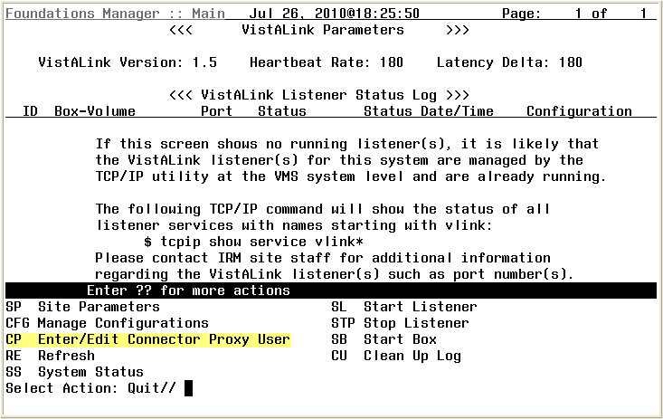
Figure 1: Screen capture of the Foundations Manager window with the CP selection highlighted.
- At the Enter NPF CONNECTOR PROXY name prompt, type CONNECTOR, EDIS.
- At the Are you adding ‘CONNECTOR, EDIS’ as a NEW PERSON prompt, type Y for yes.
- At the Want to edit ACCESS CODE prompt, type Y for yes.
- At the Enter a new ACCESS CODE <Hidden> prompt, type an access code for your EDIS connector. Remember this access code.
- At the Please re-type the new code to show that I have it right prompt, retype the new access code.
- At the Want to edit VERIFY CODE prompt, type Y for yes.
- At the Enter a new VERIFY CODE prompt, type a new verify code. Be sure to remember this code.
- At the Please re-type the new code to show that I have it right prompt, retype your new verify code. When the Foundations Manager window confirms that you have successfully changed your verify code, you have successfully created your connector proxy M account.
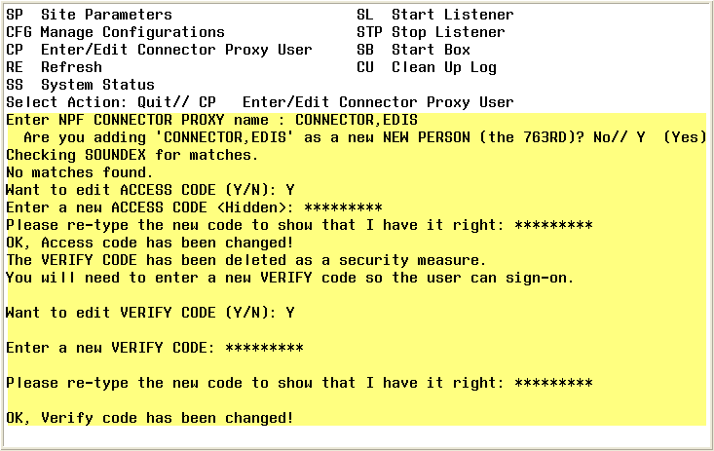
Figure 2: Screen capture of the Foundations Manager window with highlighted connector proxy prompts and responses.

Check the Status of Your Site’s VistALink Listener
If you aren’t sure whether or not a VistALink listener is running in your account, please check by performing the following steps on a Windows workstation that is connected to the VA network:
- Open a command prompt. You can open a command prompt from the Start menu in either of two ways:
  - Click Start, then All Programs, then Accessories, and then Command Prompt.
  - Click Start and then click Run. In the Run dialog’s Open box, type cmd.exe.
- At the command prompt, type the word telnet, press the <Spacebar> key, and then type the IP address and port of your site’s VistALink listener. The Command Prompt window should look like the window in the following screen capture, where 10.nnn.nnn.nnn is the four-byte IP address and pppp is the port number of your VistALink listener.
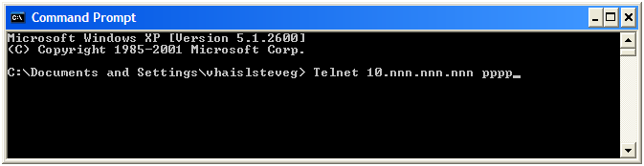
Figure 3: Screen capture of the Command Prompt window.
- Press the <Enter> key. You should see the Telnet window with the IP address showing in the window’s title bar.
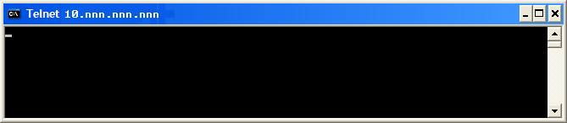
Figure 4: Screen capture of the Telnet window
- Press the <Enter> key again. The Telnet window should display an XML error message that is very similar to the error message in the following screen capture. This error message results from requesting a telnet connection to the listener. (Telnet connections are not valid for listeners.) The message lets you know that the listener is there and is listening.
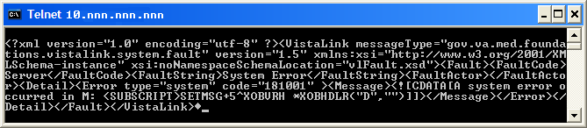
Figure 5: Screen capture of the XML telnet error message
If your listener is not present, not correctly configured, or not enabled, telnet will immediately drop your connection. You will not see an XML error message. In this event, please contact you VistALink support personnel.
- Close the Telnet window by clicking X in the upper lefthand corner.

Send VistALink Connector Information to the National Server EDIS Administrator
The next step is to send the following information to the EDIS administrator. You must send this information securely via public key infrastructure (PKI). Securely send this information for both the VistALink connector on your test VistA system and the VistALink connector on your production VistA system.
- The IP address for your site’s VistA server
- The IP address and port number of your site’s VistALink listener
- The access code for the VistALink connector
- The verify code for the VistALink connector

Add Browser Links for EDIS (You May Do This Later)
While at users’ workstations, create shortcuts to EDIS software. The URL for the EDIS production server is: http://vaww.edis.med.va.gov/main.
If you want to preselect your site on the EDIS login screen and disable users’ ability to select another site, use this URL: https://vaww.edis.med.va.gov/main/tracking.html?kaajeeDefaultInstitution=[your institution number]&kaajeeDisableInstitutionComponents=true. (For example, if your institution number is XXX, the URL you should use is https://vaww.edis.med.va.gov/main/tracking.html?kaajeeDefaultInstitution=XXX&kaajeeDisableInstitutionComponents=true.)
To create a shortcut on users’ desktops:
- Right click the desktop and select New and then select Shortcut.
- Type the URL (http://vaww.edis.med.va.gov/main) in the Type the location of the item box and then click Next.

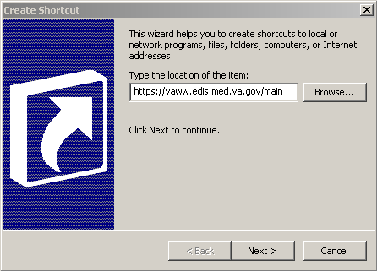
Figure 6: The Create Shortcut dialog box.

- Type a meaningful name for the shortcut in the Type a name for this shortcut box and click Finish to place the shortcut on the desktop.

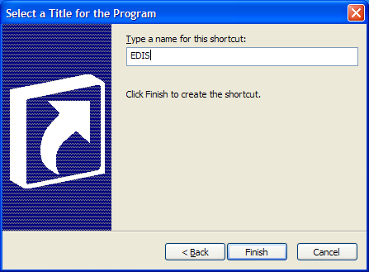
Figure 7: The Select a Title for the Program dialog box.

Install Flex Scripts on JAWS Users’ Machines (You May Do This Later)
While you are at users’ workstations, you may also want to download and install Adobe Flex accessibility scripts for users who rely on Job Access with Speech (JAWS). These scripts enable JAWS users to employ the standard keyboard shortcut to enter Forms mode on EDIS interface controls.
Download JAWS scripts for Flex 3 (an executable file) at http://www.adobe.com/accessibility/products/flex/jaws.html.
Click the executable file to install the scripts on users’ machines.

Installing M Server Components

Install the Emergency Department 1.0 Host File
Follow these instructions to install the EDIS patch. Installation time is less than one minute.
- Select Installation from the XPD MAIN option.
- From the Select Installation Option menu, select Load a Distribution.
- At the Enter a Host File prompt, type EDP1_0.KID.
- At the OK to continue with Load? NO// prompt, type YES.
- At the Want to Continue with Load? YES// confirmation, press the <Enter> key to confirm that you want to continue.
- The installation menu presents a list that includes the following options:
    - Backup a Transport Global
    - Compare Transport Global to Current System
    - Verify Checksums in Transport Global.
Select these options one by one.
- When prompted Want KIDS to Rebuild Menu Trees Upon Completion of Install? YES// respond YES.
- When prompted Want KIDS to INHIBIT LOGONs during the install? YES//, respond NO.
- When prompted Want to DISABLE Scheduled Options, Menu Options, and Protocols? YES//, respond NO.
Appendix B contains an installation example.

Edit the EDPF LOCATION Parameter
This parameter should contain the hospital location or locations that your emergency department uses. If yours is a multi-division site, make an entry for each division.
- Log in to VistA.
- At the Select OPTION NAME prompt, type xpar menu (for XPAR MENU TOOLS) and then press the <Enter> key.
- At the Select General Parameter Tools Option prompt, type ep (for Edit Parameters) and then press the <Enter> key.
- At the Select PARAMETER DEFINITION NAME prompt, type edpf l (for EDPF LOCATION), and then press the <Enter> key.
- At the Select INSTITUTION NAME prompt, type the name or station number of your institution and then press the <Enter> key.
- At the Select Time Range (ex. 0800-1200) or Sequence prompt, type the time range during which the clinic location you are about to select functions as your site’s emergency department. Use military time. For example, if the location serves as your site’s emergency department from 8:00 a.m. to 5:00 p.m., type 0800-1700. Alternately, type a number that represents the location’s preference rating (the number 1 represents the most-preferred location). Press the <Enter> key. When users create a PCE encounter, EDIS uses time-of-day-based or preference-based criteria to determine the encounter’s location.
When selecting time ranges, take care to account for all hours of emergency-department operation. EDIS does not create PCE appointments for patients whom users enter during times that you don’t include in the EDPF LOCATION parameter. For example, suppose you set the parameter to use Clinic A from 0700 to 0800 hours and Clinic B from 0900 to 1200 hours. If a user then adds a patient at 0830 hours, EDIS will not create a PCE appointment for the patient. Further, take care not to overlap hours. In cases where hours overlap, EDIS always creates the patient’s PCE appointment for the first clinic.
EDIS uses the time and preference settings you specify here to populate its Clinic list when you select the Show clinics on entry form check box in the application’s Configure view. This parameter allows users at sites that have multiple emergency-department locations to select the location EDIS will use when it creates the patient’s emergency-department visit in CPRS.
- VistA displays your new time range or selection as a default value. Press the <Enter> key to accept this default value.
- At the ED LOCATION prompt, type the name of the location that serves as your site’s emergency department during this time range or for this sequence and press the <Enter> key.
- Repeat steps 6 through 8 for additional emergency-department locations (if any).

Edit the EDPF NURSE STAFF SCREEN Parameter
The EDPF NURSE STAFF SCREEN parameter allows you to select the type of filtering EDIS uses to populate the nursing-staff selection list in its Assign Staff view. By default, the application allows all entries in the New Person (#200) file. Options for narrowing the list of possible staff selections include:
- Allow only persons who are present and active in the NURS STAFF file (#210)
- Allow only persons who hold the ORELSE key
- Allow only persons who hold the PSJ RNURSE key
- Allow selection from all entries in the New Person file (#200)

- Log in to VistA
- At the Select OPTION NAME prompt, type xpar edit parameter and press the <Enter> key.
- At the Select PARAMETER DEFINITION NAME prompt, type edpf nurse staff and press the <Enter> key.
- At the Enter selection prompt, type the number 3 (for Division) and press the <Enter> key. If your site has only one division, you can set this parameter at the system level by typing the number 5 (for System).
- At the Select INSTITUTION NAME prompt, type your institution’s name and then press the <Enter> key. VistA displays a list of criteria that EDIS can use to filter entries in the New Person (#200) file.
- At the Allow Persons prompt, type one of the following numbers to select a screening criterion and then press the <Enter> key:
    - 0 (Active in NURS STAFF (210)
    - 1 (Hold ORELSE Key)
    - 2 (Hold PSJ RNURSE Key)
    - 3 (All Persons (No Screen))

Post Installation

Convert Existing Data from the Class-III Application to EDIS (Skip This Step if Your Site Has Never Used the Syracuse Application)
You can convert data from class III (Syracuse) application files to EDIS files via a standalone option: EDP Conversion.
- At the Select OPTION NAME prompt, type EDP CONVERSION. The application displays the following information:

Select OPTION NAME: EDP CONVERSION Convert local ER data to EDIS files.
This option will copy ER configuration and visit data at your site to the new Emergency Department application. For each division, your local configuration data will be copied first, followed by all currently active patient visits. A task will then be queued to populate previous, closed visits in the national application files to allow reports to continue to function.
- The conversion option presents you with a list of your local divisions. At the Select the division you wish to convert: prompt, type the name or division number of the division whose data you want to convert and press the <Enter> key.
You can run EDP CONVERSION only once for each division.
- At the Do you wish to convert the configuration as well as the data? prompt, type YES and press the <Enter> key if you want to convert configuration data from the class-III application.
If you have already configured EDIS, EDP CONVERSION will overwrite these EDIS configurations with your class-III configurations. If you want to convert only patient data, type NO at this prompt and press the <Enter> key.
The conversion process displays the following warning:
DO NOT PROCEED UNTIL YOU ARE READY TO USE THE NEW EDIS PACKAGE!!
- If you are ready to use the new EDIS package at the division you’ve selected, type YES at the Are you ready? NO// prompt. The option initiates the conversion process and displays the following informational text:
Copying local configuration ...
Copying currently active visits ...
Task #12345 started to copy closed visits.

The Conversion Process
If you attempt to run the EDP CONVERSION option on a VistA implementation that contains no class-three data—that is, at a site that was not previously running the Syracuse application—the EDP CONVERSION option quits running and displays the following message: You have no ER data to convert.
Otherwise, the option begins the conversion process by copying your site’s class-III configuration settings to EDIS files (unless you choose not to convert these settings). You can edit these settings later to fine tune EDIS’s behavior.
The conversion option then copies all currently active visits to EDIS files and, finally, queues a background job to copy closed class-three visits to EDIS files (thus ensuring that reporting functions continue to operate accurately).
EDIS initializes a stub in the ^XTMP global when you install the application. It uses this stub to track each part of the conversion process, saving the last converted entry number in each section so it can pick up where it left off should you find it necessary to restart the conversion process. As it completes each section, the option sets the section’s ^XTMP piece to null. When the option completes the entire conversion process, it sets the node to DONE.

Restarting the Conversion Process
Follow steps 1 and 2 in section 4.1 of this guide (“Convert Existing Data from the Class-III Application to EDIS”) to restart the conversion process. The conversion option displays messages that tell you what it has already converted and what it is in the process of converting. If you restart the EDP CONVERSION option after the option has completed the conversion process, it displays the following message: All data has been converted.

Rebuild Menus
The KIDS installation process rebuilds VistA menu trees before you assign new EDIS menus. You must therefore perform a menu rebuild after you assign these menus for the first time. If you do not, graphical user interface (GUI) applications like EDIS won’t know who has access to the new options. Again, performing a menu rebuild is necessary only once for menus that have never before been assigned.
The EDIS project team recommends that you assign to yourself the EDPF TRACKING MENU ALL option—which includes all EDIS menus—and then manually rebuild VistA menu trees.

Assign Menu Options
- Log in to VistA.
- At the Select OPTION NAME prompt, type eve and then press the <Enter> key.
- At the Choose 1-5 prompt, type the number 1 (for EVE Systems Manager Menu) and press the <Enter> key.
- At the Select Systems Manager Menu Option prompt, type user (for User Management) and press the <Enter> key.
- At the Select User Management Option prompt, type edit (for Edit an Existing User) and press the <Enter> key.
- At the Select NEW PERSON NAME prompt, type your (or another user’s) name using the following format: lastname,firstname. Press the <Enter> key.
- Press the <Down Arrow> key to highlight the Select SECONDARY MENU OPTIONS field. (Type a question mark (?) to see a list of the secondary options that are currently assigned to you.)
- In the Select SECONDARY MENU OPTIONS field, type EDPF TRACKING MENU ALL and then press the <Enter> key.
- At the Are you adding …as a new SECONDARY MENU OPTIONS (the…for this NEW PERSON)? No// prompt, type Yes and press the <Enter> key.
- Press the <Enter> key again to accept this new option.
- In the SYNONYM field, type a synonym for the option (optional). Press the <Enter> key.
- Press the <Enter> key to close the COMMAND field and return to the Select SECONDARY MENU OPTIONS field.
- Type the word exit in the COMMAND field.
- At the Save changes before leaving form (Y/N)? prompt, type the letter Y and press the <Enter> key.

Rebuild Menu Trees
Log in to VistA.
- At the Select OPTION NAME prompt, type eve and then press the <Enter> key.
- At the Choose 1-5 prompt, type the number 1 (for EVE Systems Manager Menu) and press the <Enter> key.
- At the Select Systems Manager Menu Option prompt, type the word menu (for Menu Management) and press the <Enter> key.
- At the Select Menu Management Option prompt, type the word menu (for Menu Rebuild Menu) and press the <Enter> key.
- At the Select Menu Rebuild Menu Option prompt, type the word build (for Build Primary Menu Trees) and press the <Enter> key.
- At the Do you wish to verify each primary menu? NO// prompt, press the <Enter> key to accept the default selection.
- At the Would you like to build secondary menu trees too? YES// prompt, press the <Enter> key to accept the default selection.
If you type NO in response to this question, VistA will remove access to all EDIS options for all users.
- At the Would you like to queue this job? YES// prompt, press the <Enter> key to accept the default selection. If you want to run the job immediately, type NO, and then press the <Enter> key. If you choose the latter option, be advised that running a menu rebuild can take time.
- At the Requested Start Time: NOW// prompt, press the <Enter> key to accept the default selection.

After the system runs the menu rebuild, remove the menu options you don’t need.

Assign Options for Emergency Department Users
You must assign to users and clinical application coordinators (CACs) at least one of the following secondary menu options. These options provide rudimentary capabilities for limiting application access based on user roles. The EDIS project team recommends working with your site’s emergency-department administrative and IT staff to determine which users should receive which menu options.

- EDPF TRACKING MENU ALL: provides access to all views
- EDPF TRACKING MENU SIGNIN: provides access to the Sign In and Display Board views—it includes the ability to add patients. This menu also provides access to the following data-entry fields:
      - Complaint for Display Board
      - Room / Area
      - Source (the source of patients’ visits)
- EDPF TRACKING MENU TRIAGE: provides access to the Triage and Display Board views—it includes the ability to add patients. This menu also provides access to the following data-entry fields:
      - Complaint for Display Board
      - Long Complaint (optional)
      - Room / Area
      - Acuity
      - Status
      - Nurse
      - Provider
      - Resident (if the Show residents on entry form parameter is enabled)
      - Source
      - Clinic (if the Show clinics on entry form parameter is enabled)
- EDPF TRACKING MENU CLINICIAN: provides access to the Update, Disposition, and Display Board views—it includes the ability to remove patients from the board and provides access to the following data-entry fields:
- Room / Area
- Status
- Provider, Resident, and Nurse staff-assignment lists
- Comments
- Disposition
- Delay Reason (if the Delay reason is required…parameter is enabled)
- Diagnosis
- EDPF TRACKING VIEW CONFIGURE: provides access to the Configure view—which includes the ability to configure rooms and areas, colors, one or multiple display boards, site-configurable parameters, and the contents of application pick lists
- EDPF TRACKING VIEW DISPOSITION: provides access to the Disposition view—it includes the ability to remove patients from the board and provides access to the following data-entry fields:
- Room / Area
- Status
- Provider
- Resident
- Disposition
- Delay Reason
- Diagnosis
- EDPF TRACKING VIEW EDIT CLOSED: provides access to the Edit Closed view, which includes the ability to edit all data-entry fields for closed visits; the EDIS project team recommends limiting access to this view
- EDPF TRACKING VIEW REPORTS: provides access to the Reports view, which includes the ability to run administrative reports; separate keys control user access to export and print privileges, and to limited-access reports (See Section 4.4, “Assign Keys for EDIS Users”)
- EDPF TRACKING VIEW SIGNIN: provides access to the Sign In view
- EDPF TRACKING VIEW STAFF: provides access to the Assign Staff view—it offers the ability to update physician-, resident-, and nursing-staff pick lists
- EDPF TRACKING VIEW TRIAGE: provides access to the Triage view
- EDPF TRACKING VIEW UPDATE: provides access to the Update view

To reiterate: work with your site’s CACs and emergency-department managers to gather a list of EDIS users and determine which views each user needs. Assign to each user only views he or she needs.
- Log in to VistA.
- At the Select OPTION NAME prompt type eve and then press the <Enter> key.
- At the Choose 1-5 prompt, type the number 1 (for EVE Systems Manager Menu) and press the <Enter> key.
- At the Select Systems Manager Menu Option prompt, type User Management and press the <Enter> key.
- At the Select User Management Option prompt, type edit (for Edit an Existing User) and press the <Enter> key.
- At the Select NEW PERSON NAME prompt, type the user’s name using the following format: lastname,firstname. Press the <Enter> key.
- Press the <Down Arrow> key to highlight the Select SECONDARY MENU OPTIONS field. (Type a question mark (?) to see a list of the secondary options that are currently assigned to the user.)
- In the SECONDARY MENU OPTIONS field, type one of the options listed above and then press the <Enter> key:
- At the Are you adding …as a new SECONDARY MENU OPTIONS (the…for this NEW PERSON)? No// prompt, type Yes and press the <Enter> key.
- Press the <Enter> key again to accept this new option.
- In the SYNONYM field, type a synonym for the option (optional). Press the <Enter> key.
- Press the <Enter> key to close the COMMAND field and return to the Select SECONDARY MENU OPTIONS field.
- Repeat steps 6 through 12 to assign other options as necessary.
- Press the <Down Arrow> key to move through the Edit Existing User dialog. At the end of each page, type the letter n in the COMMAND field to enter the following page.
- Stop on page 3.
- Check the user’s person class, which appears on page 3, to make sure the user’s person class is active.
- If the user’s person class is not active, select an active person class for the user.
- When you have entered all applicable secondary menu options and verified that the user has an active person class, type the word Exit in the COMMAND field.
- At the Save changes before leaving form (Y/N)? prompt, type the letter Y and press the <Enter> key.

Assign Keys for EDIS Users
Assign keys for users who need access to additional reporting capabilities. The following keys are available:
- EDPR EXPORT enables the export option for EDIS reports
- EDPR PROVIDER allows users to access to the Provider report, which lists statistics for each emergency department provider
- EDPR XREF provides access to the Patient XRef (cross reference) report, which associates patients’ emergency department visit numbers with their patient IDs

- Log in to VistA
- At the Select OPTION NAME prompt, type eve and then press the <Enter> key.
- At the Choose 1-5 prompt, type the number 1 (for EVE Systems Manager Menu) and then press the <Enter> key.
- At the Select Systems Manager Menu Option prompt, type menu (for Menu Management) and then press the <Enter> key.
- At the Select Menu Management Option prompt, type the word key (for Key Management) and then press the <Enter> key. .
- At the Select Key Management Option prompt, type the word allocation (for Allocation of Security Keys). Press the <Enter> key.
- At the Allocate key prompt, type the name of the security key you want to assign—EDPF EXPORT, for example. Press the <Enter> key.
- At the Holder of key prompt, type the name of the first user to whom you are assigning the key and then press the <Enter> key.
- At the Another holder prompt, type the name of a second user to whom you are assigning the key and then press the <Enter> key. Repeat this step for all users to whom you are assigning the key.
- At the You are allocating keys. Do you wish to proceed? YES// prompt, press the <Enter> key to accept the default response.

Configure Workstations to Run EDIS (If Not Done Earlier)
If the workstations that will be running EDIS have not been configured, follow the instructions in sections 2.4 through 2.7 now.
Basic EDIS installation is now complete and users may begin using EDIS.

Configure a Display Board Size
The EDIS Configure view allows users to select the optimal screen size for your site’s electronic whiteboard (or big-board) display. The application ships with the following display sizes:
- 640 x 480
- 800 x 600
- 1024 x 768
- 1280 x 800
- 1280 x 1024
If your site’s optimal display size isn’t on this list, you can add it by taking the following steps.
- Log in to VistA.
- At the Select OPTION NAME prompt, type xpar menu (for XPAR MENU TOOLS) and then press the <Enter> key.
- At the Select General Parameter Tools Option prompt, type ep (for Edit Parameter Values) and then press the <Enter> key.
- At the Select PARAMETER DEFINITION NAME prompt, type edpf screen (for EDPF SCREEN SIZES) and then press the <Enter> key.
- At the Enter selection prompt, type 5 (for Division) and then press the <Enter> key.
- At the Select INSTITUTION NAME prompt, type the name of your institution or its station number and then press the <Enter> key.
- At the Select Sequence prompt, type a number that represents the selection-list sequence in which you want the display size to appear and press the <Enter> key.
- If you are adding this sequence as a new sequence, respond to the Are you adding…as a new Sequence? Yes// prompt by pressing the <Enter> key to accept the default.
- At the Screen Size (WIDTHxHEIGHT) prompt, type the screen size you want EDIS to list and press the <Enter> key.
- Repeat steps 7 through 9 to add additional selections to the screen-size list (as needed).

See Appendix D: "Add Screen Sizes for Large Displays" for a sample dialog that adds a 1200x1920 (portrait) display to the display list.

Configure EDIS to Work with Omnicell
If your site wants EDIS to work with its Omnicell implementation, you must manually add the Omnicell event protocol (VEFS SDAM) to the EDIS EDP NEW PATIENT event.
- Open VA FileMan.
- At the Select OPTION prompt, type the number 1 (ENTER OR EDIT FILE ENTRIES).
- At the INPUT TO WHAT FILE prompt, type the word protocol (PROTOCOL).
- At the EDIT WHICH FIELD prompt, type the word item.
- At the CHOOSE 1–2 prompt, type the number 1 (ITEM (multiple)).
- At the EDIT WHICH ITEM SUB-FIELD prompt, press the <Enter> key to accept the default response (ALL).
- At the THEN EDIT FIELD prompt, press the <Enter> key without typing a response.
- At the Select PROTOCOL NAME prompt, type EDP NEW PATIENT.
- At the Select ITEM prompt, type VEFS SDAM (the Omnicell event protocol). You don’t need to respond to prompts for other fields in the ITEM multiple.

Configure EDIS Timeouts and Timeout Countdowns
EDIS uses the same parameter settings that CPRS uses for application timeouts and timeout countdowns: ORWOR TIMEOUT CHART and ORWOR TIMEOUT COUNTDOWN settings. If the ORWOR TIMEOUT CHART parameter contains a value, this value determines the amount of time that EDIS can sit idle before it displays a timeout warning and begins its countdown. If the ORWOR TIMEOUT CHART parameter contains no value, EDIS uses the value of the Timed Read (DTIME) parameter, which is available through VistA’s user-setup menu.
The value of the ORWOR TIMEOUT COUNTDOWN setting determines the length of the application’s timeout countdown.
EDIS displays its timeout message and countdown within the browser, at the bottom of users’ current EDIS views. Because JAWS cannot read this message, EDIS also sounds a chime as it begins its timeout countdown.
Figure 8: The EDIS timeout warning and countdown.

Set the EDIS (and CPRS) Timeout
You can set the ORWOR TIMEOUT CHART parameter at the system, division, and user levels.
- In XPAR MENU TOOLS, at the Select General Parameter Tools Option prompt, type EP (Edit Parameter Values) and press the <Enter> key.
- At the Select PARAMETER DEFINITION NAME prompt, type ORWOR TIMEOUT CHART and press the <Enter> key.
- At the Enter selection prompt, type the number 1 (User), 3 (Division), or 5 (System), depending upon the level at which you want to apply this timeout value.
    - If you typed the number 1 (User), type the user’s name at the Select NEW PERSON NAME prompt.
    - If you typed the number 2 (Division), type the division or institution name at the Select INSTITUTION NAME prompt.
- At the Timeout (GUI Chart) prompt, type the number of seconds that can pass with CPRS and EDIS idle before the chart or EDIS times out.
The longest number of seconds that will currently work for EDIS timeout values is 2147483 (nearly 25 days).

Backing out EDIS VistA Components
EDIS is a new package; it has its own namespace (EDP) and installs files in its own number space (230-234). (Please see section 2.1 "Check the 230-234 Number Space.”) EDIS’s interaction with other parts of VistA is mostly limited to listening for patient events. If you decide not to use EDIS after you install it, you can take the following steps to remove the application. After taking these steps, EDIS components will not run and EDIS will not interact with other VistA packages.
- Edit the Protocol file (#101) to stop EDP OR MONITOR processes from listening for ordering and scheduling events:
  - Remove EDP OR MONITOR from:
OR EVSEND RA
OR EVSEND LRCH
OR EVSEND FH
OR EVSEND PS
OR EVSEND GMRC
  - Remove EDP MONITOR from:
RA EVSEND OR
LR70 CH EVSEND OR
PS EVSEND OR
GMRC EVSEND OR
FH EVSEND OR
OR EVSEND ORG
- Delete the values your site entered in the EDPF LOCATION parameter. This will stop EDIS listening events for locations that your site identified in this parameter as emergency department locations.
- Delete the list of values for the EDPF BIGBOARD KIOSKS parameter. This will prevent large display boards from running at your site.
- To prevent end users from running EDIS software, remove user access to, or disable the following EDIS menu options:
EDPF TRACKING MENU ALL menu
EDPF TRACKING MENU CLINICIAN menu
EDPF TRACKING MENU SIGNIN menu
EDPF TRACKING M ENU TRIAGE menu
EDPF TRACKING VIEW BOARD menu
EDPF TRACKING VIEW CONFIGURE menu
EDPF TRACKING VIEW DISPOSITION menu
EDPF TRACKING VIEW EDIT CLOSED menu
EDPF TRACKING VIEW REPORTS menu
EDPF TRACKING VIEW SIGNIN menu
EDPF TRACKING VIEW STAFF menu
EDPF TRACKING VIEW TRIAGE menu
EDPF TRACKING VIEW UPDATE menu

Configure a Workstation to Run the Large Display Board
EDIS supports large displays that act as electronic whiteboards to help track patients through their visits. These big-board displays are usually large plasma or liquid crystal display (LCD) monitors. You should place these display boards carefully, with consideration for the type of information each board is configured to display. Take care to place your boards so that confidential patient data isn’t in view of people who are not authorized to see it.
Large display boards run in kiosk mode—a method of operation designed for Internet kiosks and other settings where limiting end-user interactions with applications is advisable. Kiosk mode locks down the user interface to protect applications from accidental or deliberate misuse.
To set up your big-board display, you will:
- Confirm software prerequisites
- Make hidden files and folders visible
- Configure the big-board’s power, screensaver, and sound settings
- Add your local IRM security group to the machine’s local Administrator group
- Add your machine to its own local Administrator group
- Configure auto login and auto-login lockdown for your big-board display
- Configure kiosk mode in VistA

Following are steps for setting up a large (big-board) display.

Confirm Software Prerequisites
The EDIS project team recommends using a machine that’s running a fresh installation of the VA’s gold image, which includes Adobe Flash Player and Internet Explorer (IE). Flash Player and IE must be running on the machine that you set up to run the big-board display.
You’ll be connecting this machine to the VHAMASTER domain instead of your VISN domain.

Make Hidden Files and Folders Visible
Before you set up your site’s big-board display to run in kiosk mode, you’ll need to configure the machine’s power, sound, and screensaver settings. As a first step, please make sure your system’s hidden files and folders are visible.
Go to C:\Documents and Settings. If you can see the Default User folder, skip to Section 1.3. If you cannot see this folder, please take the following steps:
- Double-click the My Computer icon on your machine’s desktop.
- Double-click Local Disc (C:) under the Hard Disk Drives heading.
- Click Tools on the main menu.
- Select Folder Options on the Tools menu. Windows displays the Folder Options dialog box.
.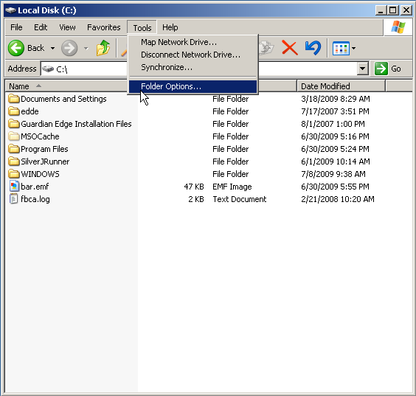
Figure 9: The Tools menu.
- Select the dialog’s View tab.
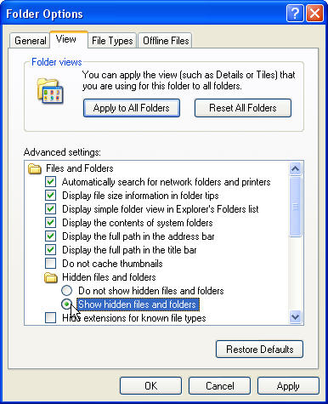
Figure 10: The Folder Options dialog box.
- Click the Hidden files and folders folder.
- Select Show hidden files and folders.
- Click Apply to All Folders in the Folder Views box.
- Click Apply. Windows displays the Folder views dialog box, which asks if you want to set all of the folders on your computer to match the current folder’s view settings.
- Click Yes.
- Click OK.

Configure the Machine’s Power, Sound, and Screensaver Settings
You’ll need to create a new user account to set up restrictions for the system’s power, sound, and screensaver settings. When you’re finished, you’ll copy the new user’s profile to your Default User Profile folder, after which you can delete the new user’s account if you want to.

Take the following steps on the machine that will power your site’s big-board display:
- Log in as a site or machine administrator. You must have local administrator rights to set the machine’s power schema.
- Right-click the My Computer icon on the machine’s desktop and select Manage. Windows displays the Computer Management dialog box.
- In the left-hand side of the pane, click to expand Local Users and Groups (under System Tools.)
- Click to open the Users folder.
- Click Action on the dialog box’s main menu and select New User. The Windows system displays the New User dialog box.
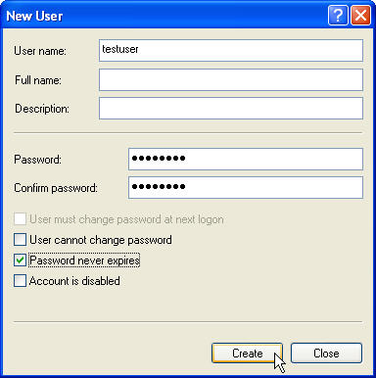
Figure 11: The New User dialog box.
- Type testuser in the User name box.
- Type a password for the testuser account in the Password box.
- Type the same password in the Confirm password box.
- Cancel the selection of the User must change password at next logon box.
- Select the Password Never Expires box.
- Click Create.
- Click Groups in the left-hand pane.
- Double-click Administrators in the right-hand pane.
- Click Add. The Windows system displays the Select Users, Computers, or Groups dialog box.
- Click Object Types and select the Users check box.
- Click Locations and select the computer’s name.
- Click OK.
- In the Enter the object names to select (examples) box, type testuser.
- Click OK. testuser should appear in the Members list.
- Click Apply.
- Log off the current administrator account.
- Log in using the newly created testuser account.

Change the Sound Control Setting to Mute
- Click the Volume icon in the system tray.
- Select the Mute check box.
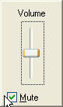
Figure 12: The Windows volume control tool.

Change Background and Screensaver Settings to None
Right-click anywhere on the Windows desktop and select Properties. Windows displays the Display Properties dialog box.
- Select the Desktop tab.
- In the Background selection box, select (None).
- Click Apply.
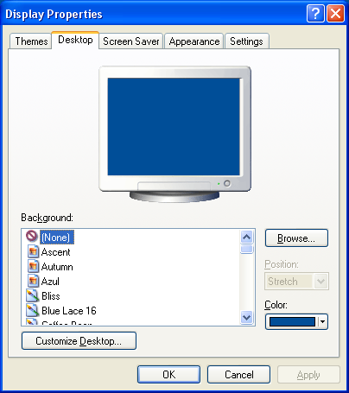
Figure 13: The Display Properties dialog box, Desktop tab.
- Select the Screen Saver tab.
- Select (None) in the Screen Saver drop-down list.
- Click Apply.
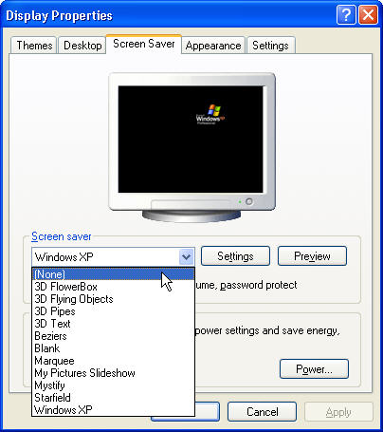
Figure 14: The Display Properties dialog box, Screen Saver tab.
- Click the Power button in the Monitor Power box. Windows displays the Power Options Properties dialog box.
- On the Power Schemes tab, expand the Power schemes drop-down list and select Presentation.
When you choose the Presentation scheme, please make sure that power settings in the Settings for Presentation power scheme box—Turn off monitor, Turn off hard disks, and System standby—are all set to Never under the Plugged in profile.
- Click Apply.
- Click OK.
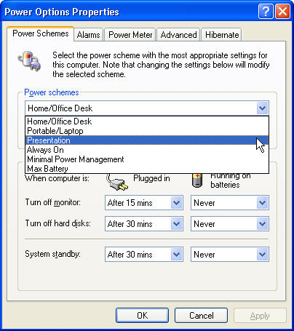
Figure 15: The Power Options Properties dialog box.
- In the Display Properties dialog box, select the Settings tab.
- Select the best screen resolution for your monitor.
Please make note of the screen resolution you select. You will need this information when you configure big-board display options in VistA. (Please see “Add a Display Board Size” in the EDIS installation guide for instructions on how to add a display-board size using the EDPF SCREEN SIZES parameter. For instructions on how to configure a display board’s screen size via the application’s Configure view, see the EDIS user guide’s “Add a New Display Board” section.)
- Click Apply.
- Click OK.

Copy the Testuser Profile Account into the Default User Account
- Log off the testuser account and log in to the local administrator account.
- Right-click on the My Computer icon and select Properties. Windows displays the System Properties dialog box.
- Select the Advanced tab.
- Click the Settings button in the User Profiles box.
- Select the testuser profile and click the Copy To button. Windows displays the Copy To dialog box.
- Click Browse and browse to the C:\Documents and Settings\Default User folder.
- Click OK.
- In the Permitted to Use and Change box, click Change. The Windows system displays the Select User or Group dialog box. In the Enter the object name to select box, type Everyone and click OK.
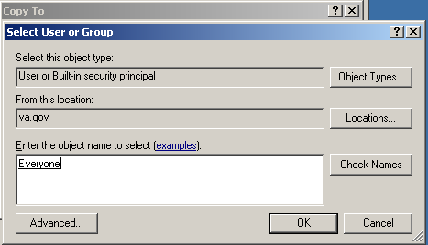
Figure 16: The Select User or Group dialog box.
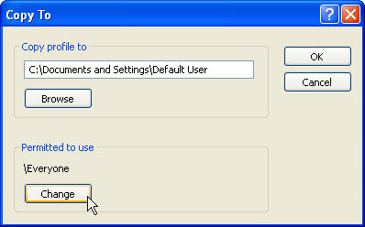
Figure 17: The Copy To dialog box.
- In the Copy To dialog box, click OK. Windows displays the Confirm Copy dialog box.
- Click Yes.
- Click OK.

Add Your Local IRM Security Group to the Machine’s Local Administrator Group.
You must add your local IRM security group to your computer’s Administrator group so that your local IRM staff can support the machine should something—a video card, for example—go awry.
- Right-click on the My Computer icon and select Manage. Windows displays the Computer Management dialog box.
- In the left-hand pane, expand Local Users and Groups.
- Select the Groups folder. Windows displays a list of the local machine’s groups in the right-hand pane.
- Double-click the Administrators group. Windows displays the Administrators Properties dialog box.
- Click the Add button.
- In the Enter the object names to select box, type VHAMASTER\[YOURIRMSECURITYGROUPNAME].
- Click OK.

Add the Machine to Its Own Local Administrator Group
You must add the display board to your computer’s Administrator group so that it will have access to the private keystores that EDIS uses for two-way Secure Sockets Layer (SSL) encryption. A group policy will ensure that the display board remains locked down.
- Right-click on the My Computer icon and select Manage. Windows displays the Computer Management dialog box.
- In the left-hand pane, expand Local Users and Groups.
- Select the Groups folder. Windows displays a list of the local machine’s groups in the right-hand pane.
- Double-click the Administrators group. Windows displays the Administrators Properties dialog box.
- Click the Add button.
- In the Enter the object names to select box, type VHAMASTER\VHAISLEDISBIGBOARD.
- Click OK.

Configure Auto Login and Auto Login Lockdown
On the computer that will power your big-board display:
- Create a folder named Vista under the Program Files directory.
- Create another folder (within the Vista folder) named EDP. The resulting directory path should look exactly like this: C:\Program Files\Vista\EDP.
- If you haven’t already done this, retrieve the EDP_1_0.zip file from an OFIO ANONYMOUS SOFTWARE directory. (See section 2.22, “Retrieve the EDP1_0.KID File and EDP_1_0.ZIP File.”)
- Extract the contents of EDP_1_0.zip to a folder on your machine’s desktop. This folder will contain the following two files: Launch_EDIS.exe and edisautologon.reg.
- Copy Launch_EDIS.exe to the EDP folder you created (C:\Program Files\Vista\EDP). The resulting directory path should look exactly like this: C:\Program Files\Vista\EDP\Launch_EDIS.exe.
- Double-click the edisautologon.reg file; this saves the registry settings that provide credentials for the EDIS auto-logon process to the machine’s registry files.
- Reboot the computer.
- Confirm that auto logon is working properly (the computer should automatically log in at this point).

Contact the VA National Helpdesk at 888.596.4357 or Create a Remedy Ticket
If you call the helpdesk, please tell the person who answers your call that you are making a display-board setup request. If you create a Remedy ticket, select the Display Board Setup Request option.
You will need to provide the fully qualified domain name of the workstation that will power the EDIS display (isl-testedis.vha.med.va.gov, for example). You must also provide the machine’s administrator account name—this is the name under which you intend to join the machine to EDIS lockdown security and EDIS auto-start groups. The helpdesk will add your machine’s name to the EDIS LockdownSecurity Group and will add your machine’s administrator account to the EDIS auto-start group.
Please wait to receive notification from EDIS helpdesk support that it has added your machine to the VHAMASTER domain.

Wait until the VA National Helpdesk Calls or Sends an Email Message to Notify You that it has Completed Your Requests.
After you receive notification that the helpdesk has completed your requests, open a new Remedy ticket asking your local IRM to add the machine to the VHAMASTER domain (vha.med.va.gov). The machine will automatically join the computer account that the helpdesk created in the proper OU.
The directory service will automatically push the EDIS Group Policy Objects (GPOs) and a SSL certificate to your machine. Please follow the instructions in section 5.9 while this push is occurring. After you complete the steps in section 5.9, you will need to log out and then immediately log back in to confirm that kiosk mode is working properly. If your machine has received the GPOs and the SSL certificate, it will automatically launch the big board. Otherwise, it will provide a relevant error message.
If kiosk mode is working properly, you may now delete the testuser account you created earlier in the process.

Configure Kiosk Mode in VistA
You must complete the following task in your VistA system before the EDIS display board can run in kiosk mode. You can perform this task while you are waiting for your machine to receive the GPOs that will run your big-board display.
Background
When the EDIS Web server receives a service request from a computer that claims to be a kiosk, the Web server requests a certificate from the requesting computer. The server uses this certificate to get the name of the computer and then does an additional check with the local VistA system to make sure the computer name is in the list of computer names that are authorized to run the kiosk.
To set up the list of authorized kiosk computer names on the VistA system:
- You must possess the EDPF KIOSKS security key; this key allows you to set up kiosks on the VistA system
- You must know the fully qualified name of the computer that will be running the kiosk; this name will look something like this: isl-testedis.vha.med.va.gov (please note that machine names now use the .vha.med.va.gov extension)

To add computer names to the list:
- Use the EDPF BIGBOARD KIOSKS option to set up the kiosk. At the Select OPTION NAME prompt, type EDPF BIGBOARD KIOSKS.
- At the Select INSTITUTION NAME prompt, type your institution’s number.
- At the Select action prompt, type Add.
- At the Computer Name prompt, type the fully qualified name of the computer.
- At the Display Board prompt, type the display board’s name.
An example:
Select OPTION NAME: EDPF BIGBOARD KIOSKS Display Board Kiosks
Select INSTITUTION NAME: SLC-DEV
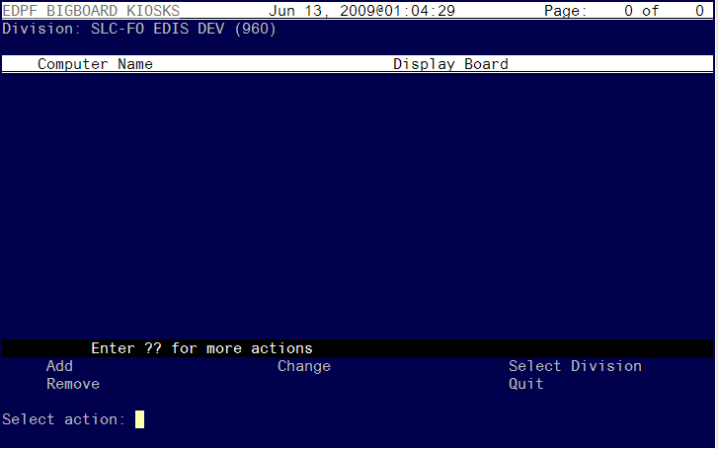
Figure 18: The Select action prompt.

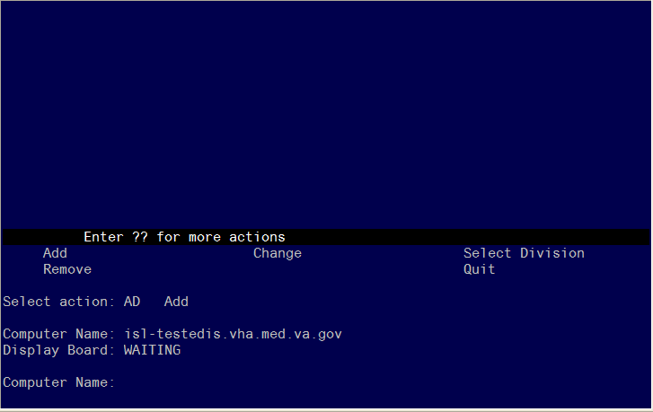
Figure 19: The Computer Name prompt.
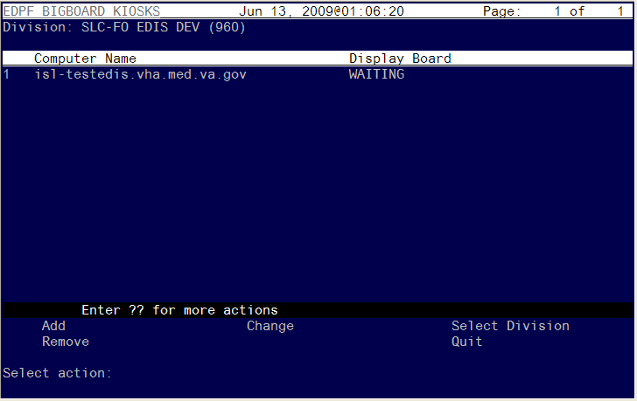
Figure 200: The Select action prompt.
You may use the other options to change and remove kiosks. It is important that the display board name match exactly the display board name that is configured in EDIS. Display-board names are case sensitive.

Add a Display Board Size
The EDIS Configure view allows you to select the optimal screen size for your site’s electronic whiteboard display. For instructions on how to configure display sizes, see section 4.6 “Configure a Display Board Size.”
For instructions on how to configure a display board’s screen size via the application’s Configure view, see the EDIS user guide’s “Add a New Display Board” section.

Confirm your settings
Reboot the computer and check to make sure:
- The EDIS big-board user auto logon is successful
- The certificate script runs successfully
- The big-board screen kiosk mode executes properly

If Necessary: Log in to the Kiosk as an Administrator
If you find it necessary to stop the auto logon process and log in to the machine as an administrator:
- Simultaneously press the <Ctrl>, <Alt>, and <Delete> keys while the big board kiosk screen is running.
- Click the Logoff button to log off the EDIS big-board user.
- When you see the VA security banner, do not click on the OK button. Instead, hold down the <Shift> key and press the <Enter> key. This will bring up the Windows login dialog box.
- Use this dialog box to log in to the machine as an administrator

You can also stop the auto logon process when the VA Security banner screen appears. Instead of clicking OK, simultaneously press the <Shift> and <Enter> keys. This will stop the auto logon process and allow you to log in as an administrator.

Appendix A—Flash Player Installation

Go to http://www.adobe.com/go/getflashplayer and click download.
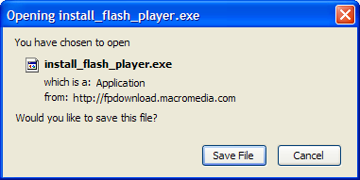
Figure 21: Install Flash Player box

Double-click the downloaded installer.
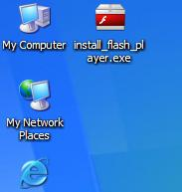
Figure 22: Install Flash Player desktop icon.

If browser windows are still open, close them and click Try Again.
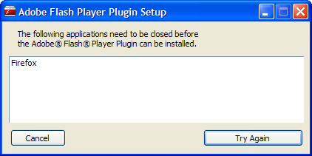
Figure 23: The Flash Player Plugin Setup dialog box.

The install should complete in a few seconds.
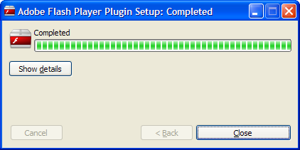
Figure 24: The Completed dialog box.

Afterward click Close. Flash Player is now installed.

Appendix B—Host File Installation

Following is an example of the EDIS host file (KIDS) installation:

226 LIST Directory transfer complete.
57018 bytes received in 00:00:01.64 seconds (33.79 Kbytes/s)
FTP> SET DEF VA5$:[CPRSTEST.EDIS]
250-CWD command successful.
250 New default directory is VA5$:[CPRSTEST.EDIS]
FTP> DIR EDP1*
200 PORT command successful.
150 Opening data connection for EDP1* (10.4.230.251,52897)

Directory VA5$:[CPRSTEST.EDIS]

EDP1_0.KID;1 948/981 25-AUG-2010 10:18:46 [CPRSTEST]
(RWED,RWED,RE,R)

Total of 1 file, 948/981 blocks

226 LIST Directory transfer complete.
172 bytes received in 00:00:00.00 seconds (18.66 Kbytes/s)
FTP> GET EDP1_0.KID
200 TYPE set to IMAGE.
200 PORT command successful.
150 Opening data connection for VA5$:[CPRSTEST.EDIS]EDP1_0.KID;1 (10.4.230.25
1,52929) (484914 bytes)
226 Transfer complete.
local: _$1$DGA719:[CLE13.ROU]EDP1_0.KID;1 remote: EDP1_0.KID
484914 bytes received in 00:00:00.71 seconds (664.17 Kbytes/s)
FTP> EXIT
221 Goodbye.
$ LO
Process CLE13_678 logged out at 25-AUG-2010 14:38:55.59
ISRA08:CLE13>d ^XUP

Setting up programmer environment
This is a TEST account.

Terminal Type set to: C-VT320

You have 201 new messages.
Select OPTION NAME: XPD MAIN Kernel Installation & Distribution System

Edits and Distribution ...
Utilities ...
Installation ...
Patch Monitor Main Menu ...

You have PENDING ALERTS
Enter "VA to jump to VIEW ALERTS option

Select Kernel Installation & Distribution System Option: INSTALLATION

1 Load a Distribution
2 Verify Checksums in Transport Global
3 Print Transport Global
4 Compare Transport Global to Current System
5 Backup a Transport Global
6 Install Package(s)
Restart Install of Package(s)
Unload a Distribution

You have PENDING ALERTS
Enter "VA to jump to VIEW ALERTS option

Select Installation Option: 1 Load a Distribution
Enter a Host File: _$1$DGA719:[CLE13.ROU]EDP1_0.KID

KIDS Distribution saved on Aug 24, 2010@14:39:19
Comment: EMERGENCY DEPARTMENT 1.0 BUILD

This Distribution contains Transport Globals for the following Package(s):
Build EMERGENCY DEPARTMENT 1.0 has been loaded before, here is when:
EMERGENCY DEPARTMENT 1.0 Install Completed
was loaded on Feb 21, 2008@18:15:30
EMERGENCY DEPARTMENT 1.0 Install Completed
was loaded on Mar 06, 2008@11:49:57
EMERGENCY DEPARTMENT 1.0 Install Completed
was loaded on Mar 06, 2008@18:00:47
EMERGENCY DEPARTMENT 1.0 Install Completed
was loaded on Mar 24, 2008@14:12:05
EMERGENCY DEPARTMENT 1.0 Install Completed
was loaded on Mar 26, 2008@17:11:27
EMERGENCY DEPARTMENT 1.0 Install Completed
was loaded on Apr 03, 2008@13:55:01
EMERGENCY DEPARTMENT 1.0 Install Completed
was loaded on Apr 10, 2008@13:20:10
EMERGENCY DEPARTMENT 1.0 Install Completed
was loaded on Apr 17, 2008@13:47:26
EMERGENCY DEPARTMENT 1.0 Install Completed
was loaded on Apr 17, 2008@15:55:56
EMERGENCY DEPARTMENT 1.0 Install Completed
was loaded on Apr 24, 2008@15:04:07
EMERGENCY DEPARTMENT 1.0 Install Completed
was loaded on May 01, 2008@15:40
EMERGENCY DEPARTMENT 1.0 Install Completed
was loaded on May 08, 2008@10:48:12
EMERGENCY DEPARTMENT 1.0 Install Completed
was loaded on May 22, 2008@16:57:21
EMERGENCY DEPARTMENT 1.0 Install Completed
was loaded on May 29, 2008@14:09:17
EMERGENCY DEPARTMENT 1.0 Install Completed
was loaded on Jun 09, 2008@15:37:26
EMERGENCY DEPARTMENT 1.0 Install Completed
was loaded on Jun 12, 2008@14:19:54
EMERGENCY DEPARTMENT 1.0 Install Completed
was loaded on Jul 29, 2008@13:45:30
EMERGENCY DEPARTMENT 1.0 Install Completed
was loaded on Aug 26, 2008@18:53:44
EMERGENCY DEPARTMENT 1.0 Install Completed
was loaded on Sep 25, 2008@11:26:08
EMERGENCY DEPARTMENT 1.0 Install Completed
was loaded on Oct 06, 2008@16:12:48
EMERGENCY DEPARTMENT 1.0 Install Completed
was loaded on Oct 20, 2008@19:38:11
EMERGENCY DEPARTMENT 1.0 Install Completed
was loaded on Nov 19, 2008@18:40:50
EMERGENCY DEPARTMENT 1.0 Install Completed
was loaded on Dec 23, 2008@18:13:25
EMERGENCY DEPARTMENT 1.0 Install Completed
was loaded on Jan 13, 2009@19:18:16
EMERGENCY DEPARTMENT 1.0 Install Completed
was loaded on Feb 04, 2009@11:45:50
EMERGENCY DEPARTMENT 1.0 Install Completed
was loaded on Jun 03, 2009@18:15:19
EMERGENCY DEPARTMENT 1.0 Install Completed
was loaded on Sep 16, 2009@13:41:51
EMERGENCY DEPARTMENT 1.0 Install Completed
was loaded on Dec 07, 2009@16:20:36
OK to continue with Load? NO// YES

Distribution OK!

Want to Continue with Load? YES// YES
Loading Distribution...

EMERGENCY DEPARTMENT 1.0
Use INSTALL NAME: EMERGENCY DEPARTMENT 1.0 to install this Distribution.

1 Load a Distribution
2 Verify Checksums in Transport Global
3 Print Transport Global
4 Compare Transport Global to Current System
5 Backup a Transport Global
6 Install Package(s)
Restart Install of Package(s)
Unload a Distribution

You have PENDING ALERTS
Enter "VA to jump to VIEW ALERTS option

Select Installation Option: 2 Verify Checksums in Transport Global
Select INSTALL NAME: EMERGENCY DEPARTMENT 1.0 Loaded from Distribution 8
/25/10@14:39:53
=> EMERGENCY DEPARTMENT 1.0 BUILD ;Created on Aug 24, 2010@14:39:19

This Distribution was loaded on Aug 25, 2010@14:39:53 with header of
EMERGENCY DEPARTMENT 1.0 BUILD ;Created on Aug 24, 2010@14:39:19
It consisted of the following Install(s):
EMERGENCY DEPARTMENT 1.0

Want each Routine Listed with Checksums: Yes// YES
DEVICE: HOME// HOME

PACKAGE: EMERGENCY DEPARTMENT 1.0 Aug 25, 2010 2:40 pm PAGE 1
-------------------------------------------------------------------------------

EDPBCF Calculated 25096927
EDPBCM Calculated 17076528
EDPBDL Calculated 11063047
EDPBKS Calculated 15371728
EDPBLK Calculated 7330093
EDPBPM Calculated 6216911
EDPBRM Calculated 24385375
EDPBRS Calculated 19077772
EDPBSL Calculated 20029785
EDPBST Calculated 8664749
EDPCBRD Calculated 4350223
EDPCDBG Calculated 4038807
EDPCONV Calculated 47887788
EDPCONV1 Calculated 10237522
EDPCSV Calculated 906612
EDPCTRL Calculated 33410398

PACKAGE: EMERGENCY DEPARTMENT 1.0 Aug 25, 2010 2:40 pm PAGE 2
-------------------------------------------------------------------------------

EDPDD Calculated 1560959
EDPFAA Calculated 5372812
EDPFLEX Calculated 1745474
EDPFMON Calculated 27211876
EDPFMOVE Calculated 43728958
EDPFPER Calculated 3427509
EDPFPTC Calculated 14885802
EDPFPTL Calculated 4915038
EDPLOG Calculated 42149061
EDPLOG1 Calculated 2583250
EDPLOGA Calculated 10789313
EDPLOGH Calculated 9457380
EDPLPCE Calculated 32802123
EDPMAIL Calculated 7335309
EDPQAR Calculated 6639632
EDPQDB Calculated 37231235
EDPQDBS Calculated 3113182

PACKAGE: EMERGENCY DEPARTMENT 1.0 Aug 25, 2010 2:40 pm PAGE 3
-------------------------------------------------------------------------------

EDPQLE Calculated 40300302
EDPQLE1 Calculated 9736825
EDPQLP Calculated 12368052
EDPQPCE Calculated 2442064
EDPRPT Calculated 17619722
EDPRPT1 Calculated 33605254
EDPRPT10 Calculated 19172294
EDPRPT11 Calculated 8054102
EDPRPT12 Calculated 7797789
EDPRPT2 Calculated 15843773
EDPRPT3 Calculated 8721424
EDPRPT4 Calculated 24084771
EDPRPT5 Calculated 35383693
EDPRPT6 Calculated 9613057
EDPRPT7 Calculated 19582712
EDPRPT7C Calculated 19611509
EDPRPT8 Calculated 14454195

PACKAGE: EMERGENCY DEPARTMENT 1.0 Aug 25, 2010 2:40 pm PAGE 4
-------------------------------------------------------------------------------

EDPRPT9 Calculated 1592058
EDPRPTBV Calculated 21129991
EDPX Calculated 9797287
EDPYPRE Calculated 8226400
EDPYPST Calculated 35872203

55 Routines checked, 0 failed.

1 Load a Distribution
2 Verify Checksums in Transport Global
3 Print Transport Global
4 Compare Transport Global to Current System
5 Backup a Transport Global
6 Install Package(s)
Restart Install of Package(s)
Unload a Distribution

You have PENDING ALERTS
Enter "VA to jump to VIEW ALERTS option

Select Installation Option: 3 Print Transport Global
Select INSTALL NAME: EMERGENCY DEPARTMENT 1.0 Loaded from Distribution 8
/25/10@14:39:53
=> EMERGENCY DEPARTMENT 1.0 BUILD ;Created on Aug 24, 2010@14:39:19

This Distribution was loaded on Aug 25, 2010@14:39:53 with header of
EMERGENCY DEPARTMENT 1.0 BUILD ;Created on Aug 24, 2010@14:39:19
It consisted of the following Install(s):
EMERGENCY DEPARTMENT 1.0

Select one of the following:

1 Print Summary
2 Print Summary and Routines
3 Print Routines

What to Print: 1 Print Summary
DEVICE: HOME// HOME
PACKAGE: EMERGENCY DEPARTMENT 1.0 Aug 25, 2010 2:40 pm PAGE 1
-------------------------------------------------------------------------------
TYPE: SINGLE PACKAGE TRACK NATIONALLY: YES
NATIONAL PACKAGE: EMERGENCY DEPARTMENT ALPHA/BETA TESTING: NO

DESCRIPTION:
This is the initial installation of the Emergency Department Information
System (EDIS). This is the module that handles tracking of a patient
through an emergency department visit. The user interface for this
application is a web application.

ENVIRONMENT CHECK: DELETE ENV ROUTINE:
PRE-INIT ROUTINE: EDPYPRE DELETE PRE-INIT ROUTINE: No
POST-INIT ROUTINE: EDPYPST DELETE POST-INIT ROUTINE: No
PRE-TRANSPORT RTN:

UP SEND DATA USER
DATE SEC. COMES SITE RSLV OVER
FILE # FILE NAME DD CODE W/FILE DATA PTRS RIDE
-------------------------------------------------------------------------------

230 ED LOG YES YES NO
PACKAGE: EMERGENCY DEPARTMENT 1.0 Aug 25, 2010 2:40 pm PAGE 2

UP SEND DATA USER
DATE SEC. COMES SITE RSLV OVER
FILE # FILE NAME DD CODE W/FILE DATA PTRS RIDE
-------------------------------------------------------------------------------

230.1 ED LOG HISTORY YES YES NO

231.7 TRACKING STAFF YES YES NO

231.8 TRACKING ROOM-BED YES YES NO

231.9 TRACKING AREA YES YES NO

233.1 TRACKING CODE YES YES YES REPL YES NO
DATA SCREEN: I $E(^(0),1,4)="edp."

233.2 TRACKING CODE SET YES YES YES REPL YES NO
DATA SCREEN: I $E(^(0),1,4)="edp."

ROUTINE: ACTION:
EDPBCF SEND TO SITE
PACKAGE: EMERGENCY DEPARTMENT 1.0 Aug 25, 2010 2:40 pm PAGE 3
-------------------------------------------------------------------------------
EDPBCM SEND TO SITE
EDPBDL SEND TO SITE
EDPBKS SEND TO SITE
EDPBLK SEND TO SITE
EDPBPM SEND TO SITE
EDPBRM SEND TO SITE
EDPBRS SEND TO SITE
EDPBSL SEND TO SITE
EDPBST SEND TO SITE
EDPCBRD SEND TO SITE
EDPCDBG SEND TO SITE
EDPCONV SEND TO SITE
EDPCONV1 SEND TO SITE
EDPCSV SEND TO SITE
EDPCTRL SEND TO SITE
EDPDD SEND TO SITE
EDPFAA SEND TO SITE
EDPFLEX SEND TO SITE
EDPFMON SEND TO SITE
EDPFMOVE SEND TO SITE
EDPFPER SEND TO SITE
PACKAGE: EMERGENCY DEPARTMENT 1.0 Aug 25, 2010 2:40 pm PAGE 4
-------------------------------------------------------------------------------
EDPFPTC SEND TO SITE
EDPFPTL SEND TO SITE
EDPLOG SEND TO SITE
EDPLOG1 SEND TO SITE
EDPLOGA SEND TO SITE
EDPLOGH SEND TO SITE
EDPLPCE SEND TO SITE
EDPMAIL SEND TO SITE
EDPQAR SEND TO SITE
EDPQDB SEND TO SITE
EDPQDBS SEND TO SITE
EDPQLE SEND TO SITE
EDPQLE1 SEND TO SITE
EDPQLP SEND TO SITE
EDPQPCE SEND TO SITE
EDPRPT SEND TO SITE
EDPRPT1 SEND TO SITE
EDPRPT10 SEND TO SITE
EDPRPT11 SEND TO SITE
EDPRPT12 SEND TO SITE
EDPRPT2 SEND TO SITE
PACKAGE: EMERGENCY DEPARTMENT 1.0 Aug 25, 2010 2:40 pm PAGE 5
-------------------------------------------------------------------------------
EDPRPT3 SEND TO SITE
EDPRPT4 SEND TO SITE
EDPRPT5 SEND TO SITE
EDPRPT6 SEND TO SITE
EDPRPT7 SEND TO SITE
EDPRPT7C SEND TO SITE
EDPRPT8 SEND TO SITE
EDPRPT9 SEND TO SITE
EDPRPTBV SEND TO SITE
EDPX SEND TO SITE

OPTION: ACTION:
EDP CONVERSION SEND TO SITE
EDPF BIGBOARD KIOSKS SEND TO SITE
EDPF TRACKING MENU ALL SEND TO SITE
EDPF TRACKING MENU CLINICIAN SEND TO SITE
EDPF TRACKING MENU SIGNIN SEND TO SITE
EDPF TRACKING MENU TRIAGE SEND TO SITE
EDPF TRACKING SYSTEM SEND TO SITE
EDPF TRACKING VIEW BOARD SEND TO SITE
EDPF TRACKING VIEW CONFIGURE SEND TO SITE
PACKAGE: EMERGENCY DEPARTMENT 1.0 Aug 25, 2010 2:40 pm PAGE 6
-------------------------------------------------------------------------------
EDPF TRACKING VIEW DISPOSITION SEND TO SITE
EDPF TRACKING VIEW EDIT CLOSED SEND TO SITE
EDPF TRACKING VIEW REPORTS SEND TO SITE
EDPF TRACKING VIEW SIGNIN SEND TO SITE
EDPF TRACKING VIEW STAFF SEND TO SITE
EDPF TRACKING VIEW TRIAGE SEND TO SITE
EDPF TRACKING VIEW UPDATE SEND TO SITE
EDPS BOARD CONTEXT SEND TO SITE

SECURITY KEY: ACTION:
EDPF KIOSKS SEND TO SITE
EDPR EXPORT SEND TO SITE
EDPR PROVIDER SEND TO SITE
EDPR XREF SEND TO SITE

PROTOCOL: ACTION:
EDP CHECK-IN SEND TO SITE
EDP MONITOR SEND TO SITE
EDP NEW PATIENT SEND TO SITE
EDP OR MONITOR SEND TO SITE
EDPF ADD BOARD SEND TO SITE
PACKAGE: EMERGENCY DEPARTMENT 1.0 Aug 25, 2010 2:40 pm PAGE 7
-------------------------------------------------------------------------------
EDPF BIGBOARD MENU SEND TO SITE
EDPF BLANK 1 SEND TO SITE
EDPF BLANK 2 SEND TO SITE
EDPF BLANK 3 SEND TO SITE
EDPF CHANGE BOARD SEND TO SITE
EDPF QUIT SEND TO SITE
EDPF REMOVE BOARD SEND TO SITE
EDPF SELECT DIVISION SEND TO SITE
FH EVSEND OR USE AS LINK FOR MENU ITEMS
GMRC EVSEND OR USE AS LINK FOR MENU ITEMS
LR7O CH EVSEND OR USE AS LINK FOR MENU ITEMS
OR EVSEND FH USE AS LINK FOR MENU ITEMS
OR EVSEND GMRC USE AS LINK FOR MENU ITEMS
OR EVSEND LRCH USE AS LINK FOR MENU ITEMS
OR EVSEND ORG USE AS LINK FOR MENU ITEMS
OR EVSEND PS USE AS LINK FOR MENU ITEMS
OR EVSEND RA USE AS LINK FOR MENU ITEMS
PS EVSEND OR USE AS LINK FOR MENU ITEMS
RA EVSEND OR USE AS LINK FOR MENU ITEMS
SDAM APPOINTMENT EVENTS USE AS LINK FOR MENU ITEMS
PACKAGE: EMERGENCY DEPARTMENT 1.0 Aug 25, 2010 2:40 pm PAGE 8
-------------------------------------------------------------------------------

LIST TEMPLATE: ACTION:
EDPF BIGBOARD KIOSKS SEND TO SITE

PARAMETER DEFINITION: ACTION:
EDPF BIGBOARD KIOSKS SEND TO SITE
EDPF DEBUG START TIME SEND TO SITE
EDPF LOCATION SEND TO SITE
EDPF NURSE STAFF SCREEN SEND TO SITE
EDPF SCHEDULING TRIGGER SEND TO SITE
EDPF SCREEN SIZES SEND TO SITE

REMOTE PROCEDURE: ACTION:
EDPCBRD RPC SEND TO SITE
EDPCTRL RPC SEND TO SITE
Press RETURN to continue:

1 Load a Distribution
2 Verify Checksums in Transport Global
3 Print Transport Global
4 Compare Transport Global to Current System
5 Backup a Transport Global
6 Install Package(s)
Restart Install of Package(s)
Unload a Distribution

You have PENDING ALERTS
Enter "VA to jump to VIEW ALERTS option

Select Installation Option: 4 Compare Transport Global to Current System
Select INSTALL NAME: EMERGENCY DEPARTMENT 1.0 Loaded from Distribution 8
/25/10@14:39:53
=> EMERGENCY DEPARTMENT 1.0 BUILD ;Created on Aug 24, 2010@14:39:19

This Distribution was loaded on Aug 25, 2010@14:39:53 with header of
EMERGENCY DEPARTMENT 1.0 BUILD ;Created on Aug 24, 2010@14:39:19
It consisted of the following Install(s):
EMERGENCY DEPARTMENT 1.0

Select one of the following:

1 Full Comparison
2 Second line of Routines only
3 Routines only
4 Old style Routine compare

Type of Compare: 1 Full Comparison
DEVICE: HOME// HOME

Compare KIDS package EMERGENCY DEPARTMENT 1.0 to current site (Disk)
Site: TEST.CLEVELAND.MED.VA.GOV UCI: CLE13,ROU Aug 25, 2010@14:40:51
KIDS Disk
-------------------------------------------------------------------------------

Routine: EDPBCF
2{ ;;1.0;EMERGENCY DEPARTMENT;;Sep 3} 2{ ;;1.0;EMERGENCY DEPARTMENT;;Sep 3}
{0, 2009;Build 71} {0, 2009;Build 70}
^ ^

Routine: EDPBCM
2{ ;;1.0;EMERGENCY DEPARTMENT;;Sep 3} 2{ ;;1.0;EMERGENCY DEPARTMENT;;Sep 3}
{0, 2009;Build 71} {0, 2009;Build 70}
^ ^

Routine: EDPBDL
2{ ;;1.0;EMERGENCY DEPARTMENT;;Sep 3} 2{ ;;1.0;EMERGENCY DEPARTMENT;;Sep 3}
{0, 2009;Build 71} {0, 2009;Build 70}
^ ^

Routine: EDPBKS
2{ ;;1.0;EMERGENCY DEPARTMENT;;Sep 3} 2{ ;;1.0;EMERGENCY DEPARTMENT;;Sep 3}
{0, 2009;Build 71} {0, 2009;Build 70}
^ ^

Routine: EDPBLK
2{ ;;1.0;EMERGENCY DEPARTMENT;;Sep 3} 2{ ;;1.0;EMERGENCY DEPARTMENT;;Sep 3}
{0, 2009;Build 71} {0, 2009;Build 70}
^ ^

Routine: EDPBPM
2{ ;;1.0;EMERGENCY DEPARTMENT;;Sep 3} 2{ ;;1.0;EMERGENCY DEPARTMENT;;Sep 3}
{0, 2009;Build 71} {0, 2009;Build 70}
^ ^

Routine: EDPBRM
2{ ;;1.0;EMERGENCY DEPARTMENT;;Sep 3} 2{ ;;1.0;EMERGENCY DEPARTMENT;;Sep 3}
{0, 2009;Build 71} {0, 2009;Build 70}
^ ^

Routine: EDPBRS
2{ ;;1.0;EMERGENCY DEPARTMENT;;Sep 3} 2{ ;;1.0;EMERGENCY DEPARTMENT;;Sep 3}
{0, 2009;Build 71} {0, 2009;Build 70}
^ ^

Routine: EDPBSL
2{ ;;1.0;EMERGENCY DEPARTMENT;;Sep 3} 2{ ;;1.0;EMERGENCY DEPARTMENT;;Sep 3}
{0, 2009;Build 71} {0, 2009;Build 70}
^ ^

Routine: EDPBST
2{ ;;1.0;EMERGENCY DEPARTMENT;;Sep 3} 2{ ;;1.0;EMERGENCY DEPARTMENT;;Sep 3}
{0, 2009;Build 71} {0, 2009;Build 70}
^ ^

Routine: EDPCBRD
2{ ;;1.0;EMERGENCY DEPARTMENT;;Sep 3} 2{ ;;1.0;EMERGENCY DEPARTMENT;;Sep 3}
{0, 2009;Build 71} {0, 2009;Build 70}
^ ^

Routine: EDPCDBG
2{ ;;1.0;EMERGENCY DEPARTMENT;;Sep 3} 2{ ;;1.0;EMERGENCY DEPARTMENT;;Sep 3}
{0, 2009;Build 71} {0, 2009;Build 70}
^ ^

Routine: EDPCONV
2{ ;;1.0;EMERGENCY DEPARTMENT;;Sep 3} 2{ ;;1.0;EMERGENCY DEPARTMENT;;Sep 3}
{0, 2009;Build 71} {0, 2009;Build 70}
^ ^

Routine: EDPCONV1
2{ ;;1.0;EMERGENCY DEPARTMENT;;Sep 3} 2{ ;;1.0;EMERGENCY DEPARTMENT;;Sep 3}
{0, 2009;Build 71} {0, 2009;Build 70}
^ ^

Routine: EDPCSV
2{ ;;1.0;EMERGENCY DEPARTMENT;;Sep 3} 2{ ;;1.0;EMERGENCY DEPARTMENT;;Sep 3}
{0, 2009;Build 71} {0, 2009;Build 70}
^ ^

Routine: EDPCTRL
2{ ;;1.0;EMERGENCY DEPARTMENT;;Sep 3} 2{ ;;1.0;EMERGENCY DEPARTMENT;;Sep 3}
{0, 2009;Build 71} {0, 2009;Build 70}
^ ^

Routine: EDPDD
2{ ;;1.0;EMERGENCY DEPARTMENT;;Sep 3} 2{ ;;1.0;EMERGENCY DEPARTMENT;;Sep 3}
{0, 2009;Build 71} {0, 2009;Build 70}
^ ^

Routine: EDPFAA
2{ ;;1.0;EMERGENCY DEPARTMENT;;Sep 3} 2{ ;;1.0;EMERGENCY DEPARTMENT;;Sep 3}
{0, 2009;Build 71} {0, 2009;Build 70}
^ ^

Routine: EDPFLEX
2{ ;;1.0;EMERGENCY DEPARTMENT;;Sep 3} 2{ ;;1.0;EMERGENCY DEPARTMENT;;Sep 3}
{0, 2009;Build 71} {0, 2009;Build 70}
^ ^

Routine: EDPFMON
2{ ;;1.0;EMERGENCY DEPARTMENT;;Sep 3} 2{ ;;1.0;EMERGENCY DEPARTMENT;;Sep 3}
{0, 2009;Build 71} {0, 2009;Build 70}
^ ^

Routine: EDPFMOVE
2{ ;;1.0;EMERGENCY DEPARTMENT;;Sep 3} 2{ ;;1.0;EMERGENCY DEPARTMENT;;Sep 3}
{0, 2009;Build 71} {0, 2009;Build 70}
^ ^

Routine: EDPFPER
2{ ;;1.0;EMERGENCY DEPARTMENT;;Sep 3} 2{ ;;1.0;EMERGENCY DEPARTMENT;;Sep 3}
{0, 2009;Build 71} {0, 2009;Build 70}
^ ^

Routine: EDPFPTC
2{ ;;1.0;EMERGENCY DEPARTMENT;;Sep 3} 2{ ;;1.0;EMERGENCY DEPARTMENT;;Sep 3}
{0, 2009;Build 71} {0, 2009;Build 70}
^ ^

Routine: EDPFPTL
2{ ;;1.0;EMERGENCY DEPARTMENT;;Sep 3} 2{ ;;1.0;EMERGENCY DEPARTMENT;;Sep 3}
{0, 2009;Build 71} {0, 2009;Build 70}
^ ^

Routine: EDPLOG
2{ ;;1.0;EMERGENCY DEPARTMENT;;Sep 3} 2{ ;;1.0;EMERGENCY DEPARTMENT;;Sep 3}
{0, 2009;Build 71} {0, 2009;Build 70}
^ ^

Routine: EDPLOG1
2{ ;;1.0;EMERGENCY DEPARTMENT;;Sep 3} 2{ ;;1.0;EMERGENCY DEPARTMENT;;Sep 3}
{0, 2009;Build 71} {0, 2009;Build 70}
^ ^

Routine: EDPLOGA
2{ ;;1.0;EMERGENCY DEPARTMENT;;Sep 3} 2{ ;;1.0;EMERGENCY DEPARTMENT;;Sep 3}
{0, 2009;Build 71} {0, 2009;Build 70}
^ ^

Routine: EDPLOGH
2{ ;;1.0;EMERGENCY DEPARTMENT;;Sep 3} 2{ ;;1.0;EMERGENCY DEPARTMENT;;Sep 3}
{0, 2009;Build 71} {0, 2009;Build 70}
^ ^

Routine: EDPLPCE
2{ ;;1.0;EMERGENCY DEPARTMENT;;Sep 3} 2{ ;;1.0;EMERGENCY DEPARTMENT;;Sep 3}
{0, 2009;Build 71} {0, 2009;Build 70}
^ ^

Routine: EDPMAIL
2{ ;;1.0;EMERGENCY DEPARTMENT;;Sep 3} 2{ ;;1.0;EMERGENCY DEPARTMENT;;Sep 3}
{0, 2009;Build 71} {0, 2009;Build 70}
^ ^

Routine: EDPQAR
2{ ;;1.0;EMERGENCY DEPARTMENT;;Sep 3} 2{ ;;1.0;EMERGENCY DEPARTMENT;;Sep 3}
{0, 2009;Build 71} {0, 2009;Build 70}
^ ^

Routine: EDPQDB
2{ ;;1.0;EMERGENCY DEPARTMENT;;Sep 3} 2{ ;;1.0;EMERGENCY DEPARTMENT;;Sep 3}
{0, 2009;Build 71} {0, 2009;Build 70}
^ ^

Routine: EDPQDBS
2{ ;;1.0;EMERGENCY DEPARTMENT;;Sep 3} 2{ ;;1.0;EMERGENCY DEPARTMENT;;Sep 3}
{0, 2009;Build 71} {0, 2009;Build 70}
^ ^

Routine: EDPQLE
2{ ;;1.0;EMERGENCY DEPARTMENT;;Sep 3} 2{ ;;1.0;EMERGENCY DEPARTMENT;;Sep 3}
{0, 2009;Build 71} {0, 2009;Build 70}
^ ^

Routine: EDPQLE1
2{ ;;1.0;EMERGENCY DEPARTMENT;;Sep 3} 2{ ;;1.0;EMERGENCY DEPARTMENT;;Sep 3}
{0, 2009;Build 71} {0, 2009;Build 70}
^ ^

Routine: EDPQLP
2{ ;;1.0;EMERGENCY DEPARTMENT;;Sep 3} 2{ ;;1.0;EMERGENCY DEPARTMENT;;Sep 3}
{0, 2009;Build 71} {0, 2009;Build 70}
^ ^

Routine: EDPQPCE
2{ ;;1.0;EMERGENCY DEPARTMENT;;Sep 3} 2{ ;;1.0;EMERGENCY DEPARTMENT;;Sep 3}
{0, 2009;Build 71} {0, 2009;Build 70}
^ ^

Routine: EDPRPT
2{ ;;1.0;EMERGENCY DEPARTMENT;;Sep 3} 2{ ;;1.0;EMERGENCY DEPARTMENT;;Sep 3}
{0, 2009;Build 71} {0, 2009;Build 70}
^ ^

Routine: EDPRPT1
2{ ;;1.0;EMERGENCY DEPARTMENT;**1**;} 2{ ;;1.0;EMERGENCY DEPARTMENT;**1**;}
{Sep 30, 2009;Build 71} {Sep 30, 2009;Build 70}
^ ^

Routine: EDPRPT10
2{ ;;1.0;EMERGENCY DEPARTMENT;;Sep 3} 2{ ;;1.0;EMERGENCY DEPARTMENT;;Sep 3}
{0, 2009;Build 71} {0, 2009;Build 70}
^ ^

Routine: EDPRPT11
2{ ;;1.0;EMERGENCY DEPARTMENT;;Sep 3} 2{ ;;1.0;EMERGENCY DEPARTMENT;;Sep 3}
{0, 2009;Build 71} {0, 2009;Build 70}
^ ^

Routine: EDPRPT12
2{ ;;1.0;EMERGENCY DEPARTMENT;;Sep 3} 2{ ;;1.0;EMERGENCY DEPARTMENT;;Sep 3}
{0, 2009;Build 71} {0, 2009;Build 70}
^ ^

Routine: EDPRPT2
2{ ;;1.0;EMERGENCY DEPARTMENT;;Sep 3} 2{ ;;1.0;EMERGENCY DEPARTMENT;;Sep 3}
{0, 2009;Build 71} {0, 2009;Build 70}
^ ^

Routine: EDPRPT3
2{ ;;1.0;EMERGENCY DEPARTMENT;;Sep 3} 2{ ;;1.0;EMERGENCY DEPARTMENT;;Sep 3}
{0, 2009;Build 71} {0, 2009;Build 70}
^ ^

Routine: EDPRPT4
2{ ;;1.0;EMERGENCY DEPARTMENT;;Sep 3} 2{ ;;1.0;EMERGENCY DEPARTMENT;;Sep 3}
{0, 2009;Build 71} {0, 2009;Build 70}
^ ^

Routine: EDPRPT5
2{ ;;1.0;EMERGENCY DEPARTMENT;;Sep 3} 2{ ;;1.0;EMERGENCY DEPARTMENT;;Sep 3}
{0, 2009;Build 71} {0, 2009;Build 70}
^ ^

Routine: EDPRPT6
2{ ;;1.0;EMERGENCY DEPARTMENT;;Sep 3} 2{ ;;1.0;EMERGENCY DEPARTMENT;;Sep 3}
{0, 2009;Build 71} {0, 2009;Build 70}
^ ^

Routine: EDPRPT7
2{ ;;1.0;EMERGENCY DEPARTMENT;;Sep 3} 2{ ;;1.0;EMERGENCY DEPARTMENT;;Sep 3}
{0, 2009;Build 71} {0, 2009;Build 70}
^ ^

Routine: EDPRPT7C
2{ ;;1.0;EMERGENCY DEPARTMENT;;Sep 3} 2{ ;;1.0;EMERGENCY DEPARTMENT;;Sep 3}
{0, 2009;Build 71} {0, 2009;Build 70}
^ ^

Routine: EDPRPT8
2{ ;;1.0;EMERGENCY DEPARTMENT;;Sep 3} 2{ ;;1.0;EMERGENCY DEPARTMENT;;Sep 3}
{0, 2009;Build 71} {0, 2009;Build 70}
^ ^

Routine: EDPRPT9
2{ ;;1.0;EMERGENCY DEPARTMENT;;Sep 3} 2{ ;;1.0;EMERGENCY DEPARTMENT;;Sep 3}
{0, 2009;Build 71} {0, 2009;Build 70}
^ ^

Routine: EDPRPTBV
2{ ;;1.0;EMERGENCY DEPARTMENT;;Sep 3} 2{ ;;1.0;EMERGENCY DEPARTMENT;;Sep 3}
{0, 2009;Build 71} {0, 2009;Build 70}
^ ^

Routine: EDPX
2{ ;;1.0;EMERGENCY DEPARTMENT;;Sep 3} 2{ ;;1.0;EMERGENCY DEPARTMENT;;Sep 3}
{0, 2009;Build 71} {0, 2009;Build 70}
^ ^

Routine: EDPYPRE
2{ ;;1.0;EMERGENCY DEPARTMENT;;Sep 3} 2{ ;;1.0;EMERGENCY DEPARTMENT;;Sep 3}
{0, 2009;Build 71} {0, 2009;Build 70}
^ ^

Routine: EDPYPST
2{ ;;1.0;EMERGENCY DEPARTMENT;;Sep 3} 2{ ;;1.0;EMERGENCY DEPARTMENT;;Sep 3}
{0, 2009;Build 71} {0, 2009;Build 70}
^ ^

-------------------------------------------------------------------------------
ENTRIES IN FILE #101 (PROTOCOL)
PROTOCOL: EDP MONITOR
TIMESTAMP: 61619,57148 TIMESTAMP: 61702,58838
PROTOCOL: EDP CHECK-IN
TIMESTAMP: 61619,57148 TIMESTAMP: 61702,58838
PROTOCOL: EDP OR MONITOR
TIMESTAMP: 61619,57148 TIMESTAMP: 61702,58838
PROTOCOL: EDP NEW PATIENT
TIMESTAMP: 61619,57148 TIMESTAMP: 61702,58838
PROTOCOL: EDPF ADD BOARD
TIMESTAMP: 61619,57148 TIMESTAMP: 61702,58838
PROTOCOL: EDPF REMOVE BOARD
TIMESTAMP: 61619,57148 TIMESTAMP: 61702,58838
PROTOCOL: EDPF CHANGE BOARD
TIMESTAMP: 61619,57148 TIMESTAMP: 61702,58838
PROTOCOL: EDPF SELECT DIVISION
TIMESTAMP: 61619,57148 TIMESTAMP: 61702,58838

PROTOCOL: EDPF BIGBOARD MENU

*ADD* ITEM Multiple: IBCE EXTR MENU

*ADD* ITEM Multiple: IBCE EXTR PRINT

*ADD* ITEM Multiple: IBCE EXTR CLON/AUTH

*ADD* ITEM Multiple: IBCE RULE ACTIVE ONLY

*ADD* ITEM Multiple: IBCEM CSA MULTI SELECT REVIEW

*ADD* ITEM Multiple: IBCEM COB VEOB MENU

*ADD* ITEM Multiple: IBCEM COB REVIEW STATUS

*ADD* ITEM Multiple: IBCEM COB EOB
TIMESTAMP: 61619,57148 TIMESTAMP: 61702,58838
PROTOCOL: EDPF BLANK 1
TIMESTAMP: 61619,57148 TIMESTAMP: 61702,58838

PROTOCOL: EDPF BLANK 2
TIMESTAMP: 61619,57148 TIMESTAMP: 61702,58838
PROTOCOL: EDPF BLANK 3
TIMESTAMP: 61619,57148 TIMESTAMP: 61702,58838
PROTOCOL: EDPF QUIT
TIMESTAMP: 61619,57148 TIMESTAMP: 61702,58838

-------------------------------------------------------------------------------
ENTRIES IN FILE #19 (OPTION)
OPTION: EDPF TRACKING SYSTEM

*ADD* RPC Multiple: EDPCTRL RPC

*ADD* RPC Multiple: EDPCBRD RPC
OPTION: EDPS BOARD CONTEXT

*ADD* RPC Multiple: EDPCBRD RPC

1 Load a Distribution
2 Verify Checksums in Transport Global
3 Print Transport Global
4 Compare Transport Global to Current System
5 Backup a Transport Global
6 Install Package(s)
Restart Install of Package(s)
Unload a Distribution

You have PENDING ALERTS
Enter "VA to jump to VIEW ALERTS option

Select Installation Option: 6 Install Package(s)
Select INSTALL NAME: EMERGENCY DEPARTMENT 1.0 Loaded from Distribution 8
/25/10@14:39:53
=> EMERGENCY DEPARTMENT 1.0 BUILD ;Created on Aug 24, 2010@14:39:19

This Distribution was loaded on Aug 25, 2010@14:39:53 with header of
EMERGENCY DEPARTMENT 1.0 BUILD ;Created on Aug 24, 2010@14:39:19
It consisted of the following Install(s):
EMERGENCY DEPARTMENT 1.0
Checking Install for Package EMERGENCY DEPARTMENT 1.0

Install Questions for EMERGENCY DEPARTMENT 1.0

Incoming Files:

230 ED LOG
Note: You already have the 'ED LOG' File.

230.1 ED LOG HISTORY
Note: You already have the 'ED LOG HISTORY' File.

231.7 TRACKING STAFF
Note: You already have the 'TRACKING STAFF' File.

231.8 TRACKING ROOM-BED
Note: You already have the 'TRACKING ROOM-BED' File.

231.9 TRACKING AREA
Note: You already have the 'TRACKING AREA' File.

233.1 TRACKING CODE (including data)
Note: You already have the 'TRACKING CODE' File.
I will REPLACE your data with mine.

233.2 TRACKING CODE SET (including data)
Note: You already have the 'TRACKING CODE SET' File.
I will REPLACE your data with mine.

Want KIDS to Rebuild Menu Trees Upon Completion of Install? YES//

Want KIDS to INHIBIT LOGONs during the install? YES// NO
Want to DISABLE Scheduled Options, Menu Options, and Protocols? YES// NO

Enter the Device you want to print the Install messages.
You can queue the install by enter a 'Q' at the device prompt.
Enter a '^' to abort the install.

DEVICE: HOME// HOME
--------------------------------------------------------------------------------

Install Started for EMERGENCY DEPARTMENT 1.0 :
Aug 25, 2010@14:42:18

Build Distribution Date: Aug 24, 2010

Installing Routines:
Aug 25, 2010@14:42:19

Running Pre-Install Routine: ^EDPYPRE

Installing Data Dictionaries:
Aug 25, 2010@14:42:19

Installing Data:
Aug 25, 2010@14:42:19

Installing PACKAGE COMPONENTS:

Installing SECURITY KEY

Installing PROTOCOL

Installing REMOTE PROCEDURE

Installing LIST TEMPLATE

Installing OPTION

Installing PARAMETER DEFINITION
Aug 25, 2010@14:42:20

Running Post-Install Routine: ^EDPYPST

Updating Routine file...

Updating KIDS files...

EMERGENCY DEPARTMENT 1.0 Installed.
Aug 25, 2010@14:42:20

Not a production UCI

NO Install Message sent

Call MENU rebuild

Starting Menu Rebuild: Aug 25, 2010@14:42:22

Collecting primary menus in the New Person file...

Primary menus found in the New Person file
------------------------------------------

OPTION NAME MENU TEXT # OF LAST LAST
USERS USED BUILT

XMUSER MailMan Menu 554 01/15/08 08/23/10
EVE Systems Manager Menu 176 08/25/10 08/23/10
SDMGR Scheduling Manager's Menu 10 12/08/04 08/23/10
SDAPP Appointment Menu 17 07/14/05 08/23/10
SDZUSER Scheduling Menu 85 12/08/04 08/23/10
DG BED CONTROL Bed Control Menu 4 12/08/04 08/23/10
DG REGISTRATION MENURegistration Menu 13 08/26/05 08/23/10
DGMGR MAS MANAGER 5 12/08/04 08/23/10
DGZADMIT ADMITTING MENU 3 12/08/04 08/23/10
DGZELIG ELIGIBILITY MENU 6 12/09/04 08/23/10
DGZBEDPATCO PATIENT & BED CONTROL 23 12/08/04 08/23/10
DGZMAA MAA MENU 1 12/06/04 08/23/10
DGZACSUPER ACP SUPERVISOR MENU 3 12/08/04 08/23/10
PSO MANAGER Outpatient Pharmacy Manager 1 12/08/04 08/23/10
PSO OUTPUTS Output Reports 2 11/22/04 08/23/10
PSO USER2 Pharmacy Technician's Menu 26 10/28/09 08/23/10
DGZAPPTADM ADMITTING AND APPOINTMENTS 7 12/08/04 08/23/10
LR OUT Results menu 3 12/03/04 08/23/10
LRWARDM Ward lab menu 1 12/08/04 08/23/10
DGZCODER Coder Menu 20 12/08/04 08/23/10
DGZCANTELIG CANTON ELIG CL MENU 31 12/08/04 08/23/10
LRAP Anatomic pathology 1 12/08/04 08/23/10
LRZZSTDPROC PROCESSING MENU 5 12/08/04 08/23/10
LRZZPROCWPV3 PHLEBOTOMY MENU 11 08/22/05 08/23/10
LRZZPROC&TECH WP MENU OPTIONS 2 12/09/04 08/23/10
LRZZCHEMISTRY CHEMISTRY & HEMATOLOGY MENUS 30 12/09/04 08/23/10
LRZZDRDORER CUMULATIVE/FILEMAN OPTIONS 1 12/08/04 08/23/10
DGZMISINQ PATIENT INFORMATION 28 12/08/04 08/23/10
TOP MANAGEMENT MENU Top Management Menu 2 12/07/04 08/23/10
TOP MANAGEMENT Top Management 6 12/08/04 08/23/10
LRZZPATH ANATOMIC PATHOLOGY& LAB R... 2 12/08/04 08/23/10
LRZZCANTON LABORATORY OPTIONS 3 12/08/04 08/23/10
LRZZMICROBIOLOGY MICROBIOLOGY 7 12/08/04 08/23/10
LRZZMARGE ACCESSIONING/DATA ENTRY/R... 1 12/08/04 08/23/10
DGZMEM CLINIC REVIEW 1 12/08/04 08/23/10
LRZZCHEN CHEMISTRY 1 12/06/04 08/23/10
DGZFREXP FILE ROOM MENU 15 12/08/04 08/23/10
SDUSER Scheduling Menu 5 12/08/04 08/23/10
DGZDMU Statistics Unit Menu 3 12/08/04 08/23/10
AFXSF Sue Fuehrer's Menu 1 12/06/04 08/23/10
DGZOXYGEN Home Oxygen 1 12/08/04 08/23/10
DGZMGR MAS MANAGER 1 12/08/04 08/23/10
ZZQA Quality Assurance 1 06/29/05 08/23/10
AFVTECH IRM Technician's Menu 19 12/08/04 08/23/10
DGZMISBILL BILLING CLERK MENU 1 12/07/04 08/23/10
DGZACSUPER/HINQ AC SUPERVISOR MENU 12 12/08/04 08/23/10
DGZROSS ROSS' MENU 1 12/08/04 08/23/10
DENTMANAGER Dental 2 12/08/04 08/23/10
DENTUSER Dental 1 12/08/04 08/23/10
DENTZACTMANAGERII Dental Activity 3 12/08/04 08/23/10
IBCN INSURANCE MGMT MENU
Patient Insurance Menu 15 12/08/04 08/23/10
PSJU MGR Unit Dose Medications 2 12/08/04 08/23/10
AFVLW PS I-O PHARM MGR
I/O PHARMACY 68 08/23/05 08/23/10
ORZ AFV LOCAL HEAD NURSE
Local Head Nurse Menu 36 12/08/04 08/23/10
AFVLW PS I-O PHAR TECH
I/O PHARMACY TECHNICIAN O... 14 12/09/04 08/23/10
ZZDOCTOR Doctors Menu 1050 08/24/10 08/23/10
YSUSER Mental Health 11 12/08/04 08/23/10
DGZSWS APPOINTMENT MENU 10 12/08/04 08/23/10
ZLWLIPID Lipid Clinic 1 12/08/04 08/23/10
SOWK Information Management Sy... 6 12/08/04 08/23/10
ZIRM IRM Staff 6 12/08/04 08/23/10
DGZTRANSCRIPTION TRANSCRIPTION UNIT MENU 6 12/08/04 08/23/10
RAZTECHMENU Radiology Technologist Menu 38 12/09/04 08/23/10
RA OVERALL Rad/Nuc Med Total System ... 15 12/08/04 08/23/10
RA CLERKMENU Rad/Nuc Med Clerk Menu 1 04/03/06 08/23/10
RAZFILERM Radiology Film Librarian ... 7 12/08/04 08/23/10
RAZCLERKMENU Radiology Clerk Menu 9 12/08/04 08/23/10
DGZPATFM PATIENT FUNDS MENU 1 12/08/04 08/23/10
ORZ AFV LOCAL STAFF NURSE
Local Staff Nurse Menu 996 08/04/10 08/23/10
QAC MAIN MENU Patient Representative Ma... 2 12/08/04 08/23/10
AFV ESP POLICE USER MENU
Police User Menu 28 12/09/04 08/23/10
AFV ESP POLICE SUPERVISOR MENU
Police Supervisor Menu 10 12/09/04 08/23/10
DGZOPER OPERATOR MENU 2 12/07/04 08/23/10
AFV ACOS/EDUCATION Education Plessey Files 1 12/08/04 08/23/10
AFV QM Quality Management Files 1 12/07/04 08/23/10
PRCSCP OFFICIAL Control Point Official's ... 2 12/08/04 08/23/10
PRCHUSER PA Purchasing Agent 1 08/23/10
PRCHUSER WHSE Warehouse 4 11/24/04 08/23/10
PRCFA ACCTG TECH Accounting Technician Menu 1 10/20/04 08/23/10
PRCHPC PO Purchase Orders Menu 1 08/23/10
NURAED-MENU Administration Records, E... 1 12/08/04 08/23/10
NURS-SYS-MGR Nursing System Manager's ... 1 12/07/04 08/23/10
NURS-HN Head Nurse's Menu 1 12/08/04 08/23/10
FHDIET Clinical Dietetics 2 12/08/04 08/23/10
FHTECH Clinical Dietetics 12 12/08/04 08/23/10
ENMGR Engineering Main Menu 3 12/08/04 08/23/10
ENSP Space/Facility Management 1 12/07/04 08/23/10
IB BILLING SUPERVISOR MENU
Billing Supervisor Menu 2 12/07/04 08/23/10
FHMGRA Dietetic Administration 1 12/08/04 08/23/10
ENZAJL.BMET Biomedical Technician Menu 9 12/08/04 08/23/10
ENZAJL.CSCHIEF Construction Section Main... 2 12/08/04 08/23/10
ENZAJL.CSTECHS Construction Tech's Menu 5 12/08/04 08/23/10
ENZAJL.AA Engineering Administrativ... 3 12/08/04 08/23/10
ENZAJL.MRM M&R Shop's Main Menu 1 12/08/04 08/23/10
YSUSER3 Mental Health - LPNs and NAs 1 12/08/04 08/23/10
DIZHLPRMN PERSONNEL'S MAIN MENU 27 12/08/04 08/23/10
AFV LAB COORD Laboratory Coordinator Menu 1 12/08/04 08/23/10
YSZMD MENU FOR PSYCHIATRISTS AN... 7 12/08/04 08/23/10
AFXTF BLDGMGMT-INTDES
Interior Design Section 1 12/08/04 08/23/10
DGZMRM MAIL CLERK MENU 1 01/15/08 08/23/10
LRZZPATHCLERK PATHOLOGY CLERKS OPTION 1 12/08/04 08/23/10
LRZZPATHTECHS LAB PATHOLOGY MENU 3 12/08/04 08/23/10
LRZZPATHOLOGIST ANAT. PATH: PATHOLOGISTS 1 12/08/04 08/23/10
ABSV VOLUNTEER Volunteer Master Menu 1 09/22/04 08/23/10
ABSV TIMEKEEPING MASTER
Volunteer Timekeeping Act... 4 12/08/04 08/23/10
PRCA CLERK MENU Clerk's AR Menu 9 08/16/05 08/23/10
FBAA MAIN MENU Fee Basis Main Menu 26 12/08/04 08/23/10
FHADM Production Reports 3 12/07/04 08/23/10
RA TECHMENU Rad/Nuc Med Technologist ... 1 12/08/04 08/23/10
RA SECRETARY Rad/Nuc Med Secretary Menu 1 12/08/04 08/23/10
SROMENU Surgery Menu 7 12/08/04 08/23/10
MEDTRAN MAIN MENU MedTran Main Menu 9 12/08/04 08/23/10
AFXINC INCOMPLETE Incomplete Records Tracki... 2 12/08/04 08/23/10
DGZDGMGR MAS MANAGER 3 12/08/04 08/23/10
PRCHUSER COORDINATORIFCAP Application Coordin... 1 12/08/04 08/23/10
RTZ MAS-SUPER-MENU MAS File Room Supervisor ... 2 12/08/04 08/23/10
RT MAS-FILE-CLERK-MENU
File Clerk Menu (MAS) 1 08/23/10
ORZ DGZWARDCLERK WARD CLERK MENU-OE/HS 67 12/09/04 08/23/10
DGZDVBAROI A.M.I.E. ROI MENU 7 12/08/04 08/23/10
ENWOWARD Electronic Work Requests 14 12/08/04 08/23/10
AFXE TF NXSECTION NX Section Menu 1 12/08/04 08/23/10
AFVIRMSEC IRM Administrative Suppor... 1 12/08/04 08/23/10
QAOS MAIN MENU Occurrence Screen Manager... 3 12/08/04 08/23/10
FHZSUP DIETETICS SUPERVISORY MENU 7 12/08/04 08/23/10
GMTS USER Health Summary Menu 41 12/09/04 08/23/10
PRPF MASTER Patient Funds (INTEGRATED... 4 12/08/04 08/23/10
IB OUTPUT MENU Output IB Menu 20 05/19/10 08/23/10
IB MANAGER MENU Integrated Billing Master... 1 12/08/04 08/23/10
RTZ MAS-FILE-CLERK-MENU
MAS FILE CLERK MENU 13 12/08/04 08/23/10
OR CLINICIAN Clinician Menu 1 06/08/10 08/23/10
YSZADD1MEB26SEP91 PSYCHOLOGY SERVICE CLINIC... 30 12/08/04 08/23/10
DGZROIM ROI MENU 2 12/08/04 08/23/10
OR MAIN MENU WARD CLERK
Ward Clerk Menu 4 12/07/04 08/23/10
ORZ MAIN MENU WARD CLERK
Ward Clerk Menu-OE/RR 4 12/08/04 08/23/10
DVBA C C&P MASTER MENU
Compensation and Pension ... 1 12/08/04 08/23/10
DVBA C MEDICAL ADMIN C&P MENU
Medical Administration C&... 1 09/02/04 08/23/10
PRSD 05 EMPLOYEE INQUIRY MENU
Employee Inquiry/Reports ... 11 12/08/04 08/23/10
AFVHELP IRM Help Desk Menu 2 12/08/04 08/23/10
AFV GAJ STEVE GAJ'S PRIMARY MENU 1 12/08/04 08/23/10
RMPR OFFICIAL Prosthetic Official's Menu 3 12/08/04 08/23/10
RMPR CLERK Prosthetic Clerk's Menu 10 12/08/04 08/23/10
LRZZCOMBINE ACCESS,PROCESS & REPORTS 10 12/08/04 08/23/10
AFVPZ PS STUDENT MENU
PHARMACY STUDENT MENU 13 12/08/04 08/23/10
ENZAJL.DORAN DENNIS' MAIN MENU 1 12/07/04 08/23/10
ANRV VIST MENU VIST Menu 1 12/08/04 08/23/10
AFVENBOSS Boss's Menu 1 12/08/04 08/23/10
AFWEAC MENU ANTICOAGULATION MENU 1 12/08/04 08/23/10
HBHC INFORMATION SYSTEM MENU
HBPC Information System Menu 1 07/14/04 08/23/10
AFVCOMTECH Communications Tech Menu 3 12/08/04 08/23/10
PSO USER1 Pharmacist Menu 7 04/18/05 08/23/10
PRSA TK MENU TimeKeeper Main Menu 8 12/09/04 08/23/10
PRSA EMP MENU Employee Menu 305 09/15/09 08/23/10
PRSA SUP MENU T&A Supervisor Menu 2 12/08/04 08/23/10
PRSA OT MENU T&A OT/Supervisor Menu 1 12/07/04 08/23/10
AFXSSDOM MENU Domiciliary Management 11 12/08/04 08/23/10
AFVDSINT INTER/DESIGN SUP/MENU
Interior Design Approving... 2 12/08/04 08/23/10
LBRY MAIN MENU AFVDSLibrary Menus 1 12/06/04 08/23/10
MEDICATION PROFILE MENU
Medication Profile Menu -... 4 12/08/04 08/23/10
AFVCOS1 Chief of Staff's Menu 1 12/07/04 08/23/10
AFVDIRSTAFF Director's Office Staff 3 12/08/04 08/23/10
AFX GENERIC MAS MENUGeneric MAS Menu 1 12/08/04 08/23/10
IBD MANUAL DATA ENTRY MENU
AICS Data Entry Menu 2 12/08/04 08/23/10
AFVLW ADPAC MAIL COORD MENU
Coordinator's Mail Group ... 1 12/08/04 08/23/10
LL EVE System Manager Menu 1 12/08/04 08/23/10
AFXTF TROYSMENU Troy's Menu 1 12/08/04 08/23/10
PRCH PURCHASE CARD MENU
Purchase Card Menu 1 12/08/04 08/23/10
AFVPZ OP-UD-IV-AR/WS REPORTS
Pharmacy - All Mgmt Reports 1 12/08/04 08/23/10
PRCN NX PPM MENU Equipment Request Menu (PPM) 2 12/08/04 08/23/10
ECXMGR Extract Manager's Options 9 12/08/04 08/23/10
AFVCLAPHAM Medicine Administrative A... 1 12/03/04 08/23/10
DGPRE PRE-REGISTER MENU
Preregistration Menu 10 12/08/04 08/23/10
SWZCSWCCH Consolidated SW Menu 80 12/08/04 08/23/10
ENZAJL.M&OSUPVMENU M&O Supervisor Main Menu 14 12/08/04 08/23/10
AFVRS TEL OPERATOR Telephone Operator Menu 7 12/08/04 08/23/10
DVBA VARO REMOTE CLEVELAND VA Regional Off... 113 12/08/04 08/23/10
CLEZZ FIRST PARTY CLERK'S MENU
Menu for Pharmacy Co-Pay ... 8 12/08/04 08/23/10
TIU MAIN MENU MRT Text Integration Utilitie... 2 12/08/04 08/23/10
TIU MAIN MENU CLINICIAN
Progress Notes/Discharge ... 1 01/17/08 08/23/10
ORZ CLINICAL COORD. Clinical Coordinator Menu 8 12/08/04 08/23/10
PXRM REMINDER REPORTS
Reminder Reports 1 12/08/04 08/23/10
AFVDS SANDUSKY MENU Sandusky Inquire Menu 2 08/23/10
AFVAZZLOCALPRE-REGISTRATION
LOCAL PRE-REGISTRATION 32 12/08/04 08/23/10
AFVAZZ CHECK PROCESSING MENU
CHECK PROCESSING MENU 4 12/08/04 08/23/10
AFVAZMCCR LOCAL BILLING MENU
MCCR LOCAL BILLING MENU 29 12/08/04 08/23/10
AFVAZMCCR LOCAL ANALYST MENU
MCCR LOCAL ANALYST MENU 7 12/08/04 08/23/10
AFVDS OUTREACH MAIN MENU
Outreach Main Menu 12 12/08/04 08/23/10
AFVAZ MCCR CHIEF MCCR Chief 5 12/08/04 08/23/10
AFV PCMM MENU PCMM MENU 1 12/08/04 08/23/10
AFXTF QM NURSE MENU QM Nurse Menu 1 12/08/04 08/23/10
AFWEPE MENU Prosthetic Eyeglass 3 12/08/04 08/23/10
AFV AR CONTRACTOR'S MENU
AR Contractor's Menu 6 12/08/04 08/23/10
EDPF TRACKING MENU ALL
All Tracking Views 1 08/23/10

Building secondary menu trees....

Merging.... done.

Install Completed

1 Load a Distribution
2 Verify Checksums in Transport Global
3 Print Transport Global
4 Compare Transport Global to Current System
5 Backup a Transport Global
6 Install Package(s)
Restart Install of Package(s)
Unload a Distribution

You have PENDING ALERTS
Enter "VA to jump to VIEW ALERTS option

Select Installation Option: Timed out....

Do you want to halt and continue with this option later? YES//

Great. See you later.

Logged out at Aug 25, 2010 2:44 pm

Appendix C—Instructions for RALS-Plus Sites
If your site uses RALS software from Medical Automation Systems (AMS) and you are not planning to use Appointment Management to create emergency-department visits in the Patient Care Encounters (PCE) package, you’ll need to install an updated version of the GTS interface routine ANGBLGTS5.
The older version of this routine uses events from Appointment Management to store information from point-of-care (POC) devices in VistA. Because EDIS makes it possible to create emergency-department visits in CPRS without using Appointment Management, some sites are opting not to use this Scheduling package application. The updated version of GTS ANGBLGTS5 supports RALS interaction with VistA for sites that plan to use EDIS to create emergency-department visits.

Appendix D—Add Screen Sizes for Large Displays (Example)

Sample dialog to add a 1200x1920 (portrait) display to the EDPF SCREEN SIZES parameter file’s display list.

Select OPTION NAME: XPAR MENU TOOLS General Parameter Tools

LV List Values for a Selected Parameter
LE List Values for a Selected Entity
LP List Values for a Selected Package
LT List Values for a Selected Template
EP Edit Parameter Values
ET Edit Parameter Values with Template
EK Edit Parameter Definition Keyword

You have PENDING ALERTS
Enter "VA to jump to VIEW ALERTS option

<REMDV> Select General Parameter Tools Option: EP Edit Parameter Values
--- Edit Parameter Values ---

Select PARAMETER DEFINITION NAME: EDPF SCREEN SIZES Available Screen Sizes

EDPF SCREEN SIZES may be set for the following:

5 Division DIV [choose from INSTITUTION]
7 System SYS [EDIS-RDV.FO-SLC.MED.VA.GOV]

Enter selection: 5 Division INSTITUTION
Select INSTITUTION NAME: CHEYENNE VAMROC WY M&ROC 442

---------- Setting EDPF SCREEN SIZES for Division: CHEYENNE VAMROC ----------
Select Sequence: ?

Sequence Value
-------- -----
1 640x480
2 800x600
3 1024X768
4 1152x864
5 1280x800
6 1280x1024

Select Sequence: 7
Are you adding 7 as a new Sequence? Yes// YES

Sequence: 7// 7

Screen Size (WIDTHxHEIGHT): 1200x1920
Select Sequence: ?

Sequence Value
-------- -----
1 640x480
2 800x600
3 1024X768
4 1152x864
5 1280x800
6 1280x1024
7 1200x1920

Select Sequence:

EDPF SCREEN SIZES may be set for the following:

5 Division DIV [choose from INSTITUTION]
7 System SYS [EDIS-RDV.FO-SLC.MED.VA.GOV]

Enter selection:
-------------------------------------------------------------------------------

Select PARAMETER DEFINITION NAME:

LV List Values for a Selected Parameter
LE List Values for a Selected Entity
LP List Values for a Selected Package
LT List Values for a Selected Template
EP Edit Parameter Values
ET Edit Parameter Values with Template
EK Edit Parameter Definition Keyword

You have PENDING ALERTS
Enter "VA to jump to VIEW ALERTS option

<REMDV> Select General Parameter Tools Option:

Appendix E—Post Installation Checklist

  - Select one or more emergency-department locations (edit the EDPF LOCATION parameter)
  - Select the screening criterion that EDIS uses to populate the nursing-staff pick list
  - Assign all EDPF options to yourself or another member of the IRM staff
  - Rebuild menu trees
  - Install Adobe Flash Player 9 on users’ workstations (if necessary).
  - Work with emergency-department management staff and CACs to obtain a task-oriented checklist for EDIS users
  - Determine which menu options each user needs
  - Assign menu options
  - Make sure each user has an active person class
  - Work with emergency-department staff and CACs to determine which security keys each user needs (if any)
  - Assign security keys
  - Add the screen sizes that optimize your site’s electronic white-board displays
  - Configure workstations to run your site’s electronic white-board display

